 |  | Week 1 | Week 2 | Week 3 | Week 4 |  | Week 5
 | Key text  Talk through stories | 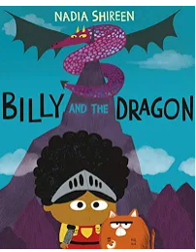 | 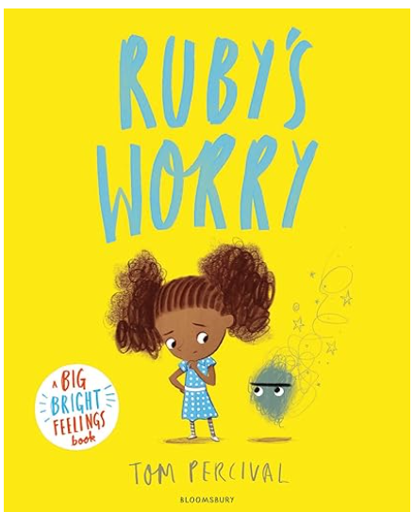 | 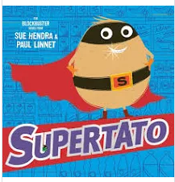 | 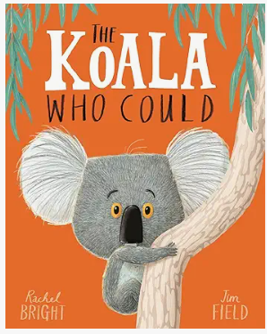 | 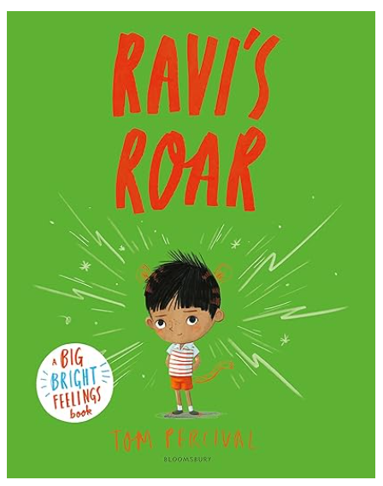
Prime areas | Communication  and Language | Oracy and listening  - Asking and answering questions  - Talking about our topic  - COOL TIME – what did my talk partner do?  - Talk through stories daily  - Daily Vocabulary work (Talk through stories)  - Re-tell a story to a small group using pictures of familiar book  - Re-tell stories through role play  - Express my point of view  - Using new Tier 2 and 3 vocab in CP and daily routines | Oracy and listening  - Asking and answering questions  - Talking about our topic  - COOL TIME – what did my talk partner do?  - Talk through stories daily  - Daily Vocabulary work (Talk through stories)  - Re-tell a story to a small group using pictures of familiar book  - Re-tell stories through role play  - Express my point of view  - Using new Tier 2 and 3 vocab in CP and daily routines | Oracy and listening  - Asking and answering questions  - Talking about our topic  - COOL TIME – what did my talk partner do?  - Talk through stories daily  - Daily Vocabulary work (Talk through stories)  - Re-tell a story to a small group using pictures of familiar book  - Re-tell stories through role play  - Express my point of view  - Using new Tier 2 and 3 vocab in CP and daily routines | Oracy and listening  - Asking and answering questions  - Talking about our topic  - COOL TIME – what did my talk partner do?  - Talk through stories daily  - Daily Vocabulary work (Talk through stories)  - Re-tell a story to a small group using pictures of familiar book  - Re-tell stories through role play  - Express my point of view  - Using new Tier 2 and 3 vocab in CP and daily routines | Oracy and listening  - Asking and answering questions  - Talking about our topic  - COOL TIME – what did my talk partner do?  - Talk through stories daily  - Daily Vocabulary work (Talk through stories)  - Re-tell a story to a small group using pictures of familiar book  - Re-tell stories through role play  - Express my point of view  - Using new Tier 2 and 3 vocab in CP and daily routines
 | Nursery Rhyme | A sailor went to sea | 5 little speckled frogs | This little piggy | Row, row, row the boat | London bridge is falling down
 | Speaking
 | Physical Dev  Gross Motor | 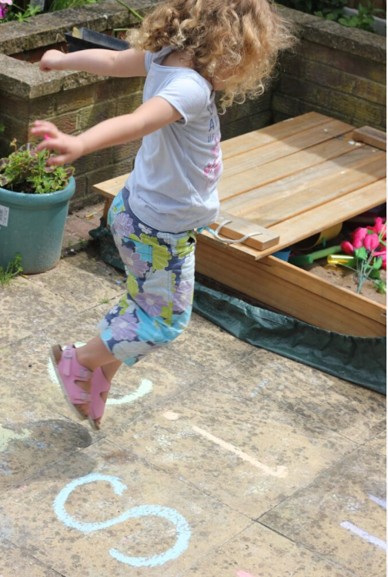  Long jumps and measuring jumps | 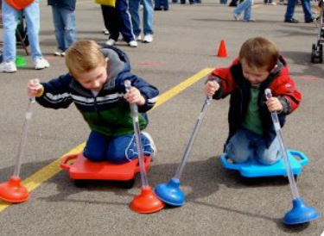 | 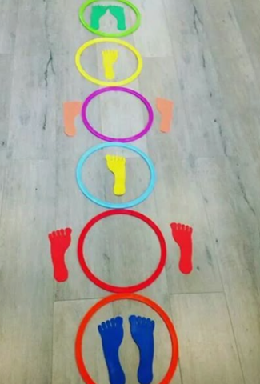 |  | 
 | PE | Multi-skills,  Striking and  Fielding Games | Multi-skills,  Striking and  Fielding Games | Multi-skills,  Striking and  Fielding Games | Multi-skills,  Striking and  Fielding Games | Multi-skills,  Striking and  Fielding Games
 | Fine motor skills | 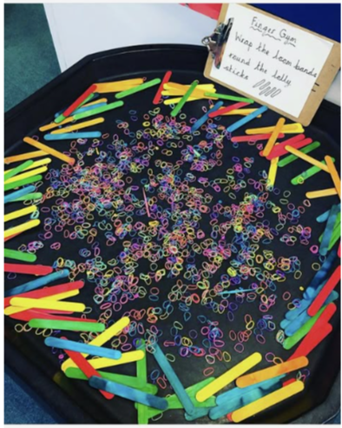  Loom bands onto lolly sticks | 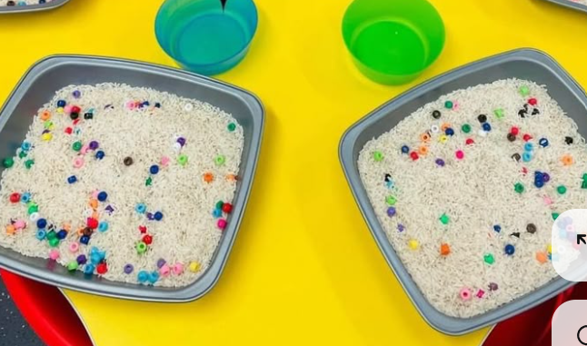  Picking beads out of rice against timer and race a friend. Who has  the most in 1 minute? | 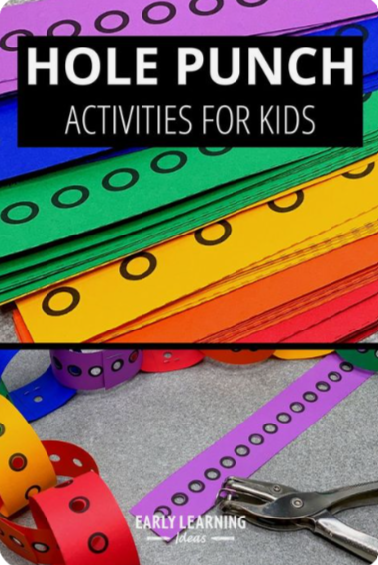 | 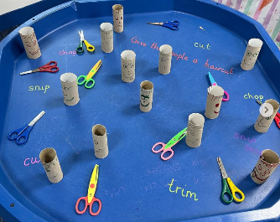  Trim the hair (snip toilet roll tubes with faces) | 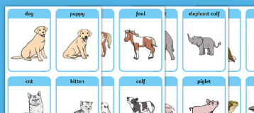  Pictures of animals and their babies….children to then paperclip the adult and baby pictures together.
 | Finger Fit
 |  | Based on –  Billy and the dragon  Monday  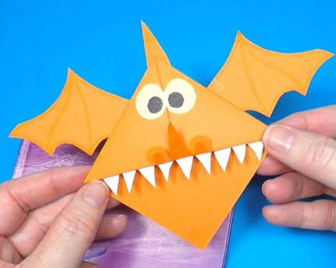  Tuesday    Wednesday  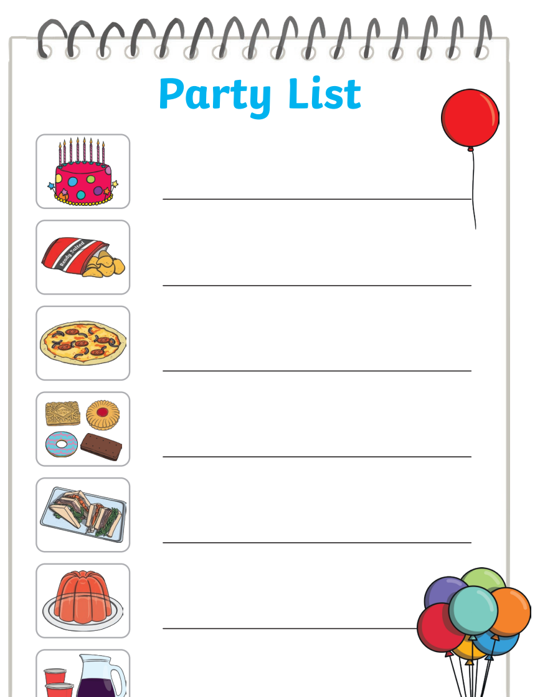  Thursday  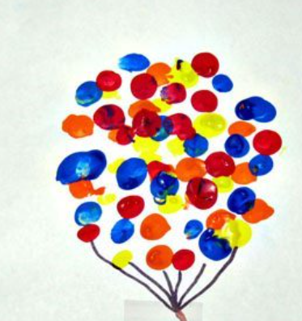 | Based on –  Ruby’s Worry  Monday  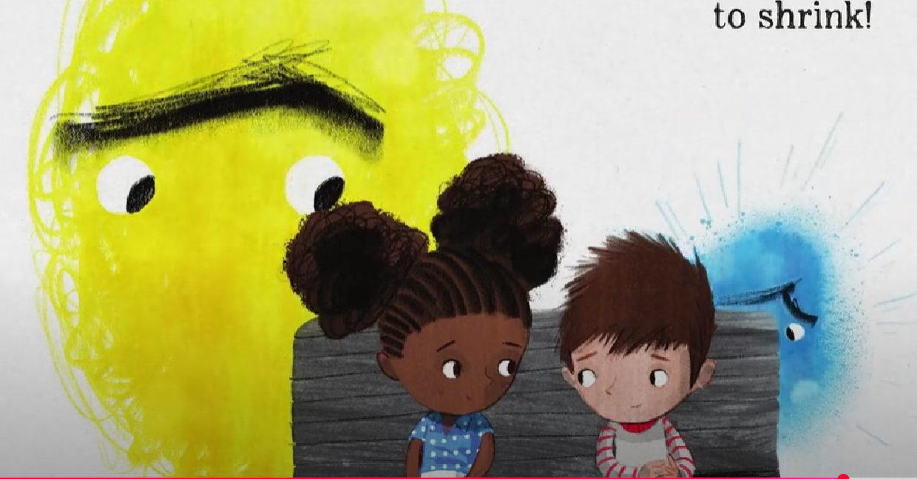  Stick boy and Ruby onto bench and then draw worries  Tuesday  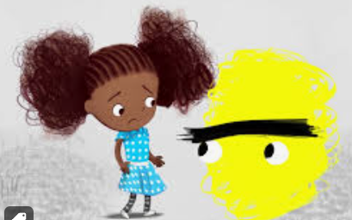  Lift the flap – children draw own worry on front and open to reveal who they would talk to  Wednesday  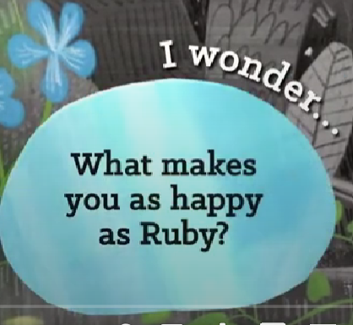  Draw what makes you happy  Thursday  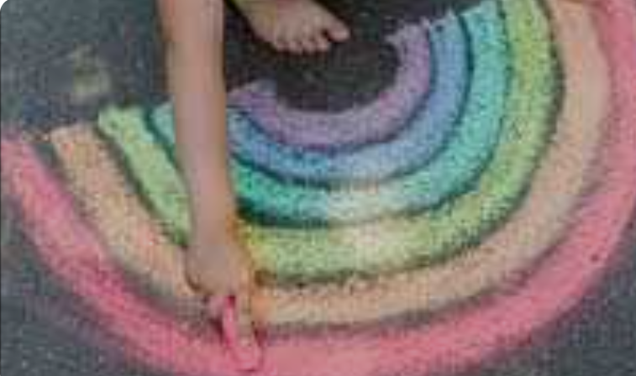 | Based on –  Supertato  Monday  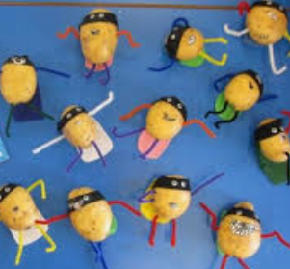  Tuesday  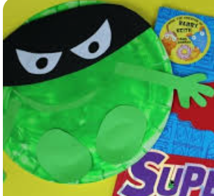  Wednesday  Design an Evil Pea trap  Thursday  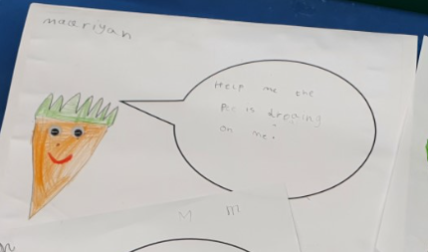 | Based on –  Monday  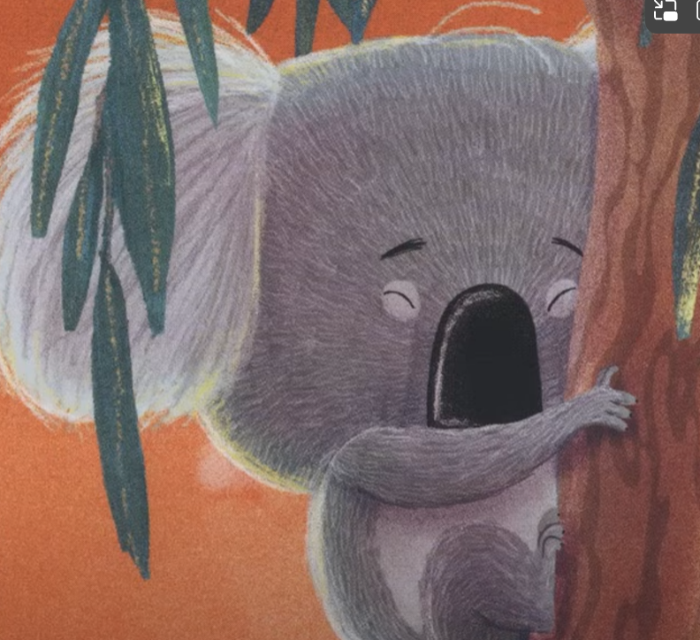  Tuesday  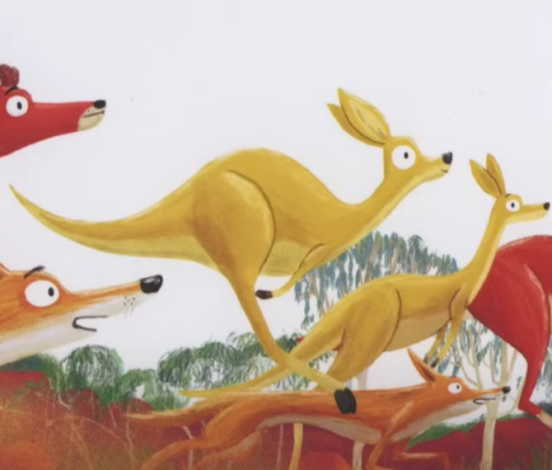  Wednesday  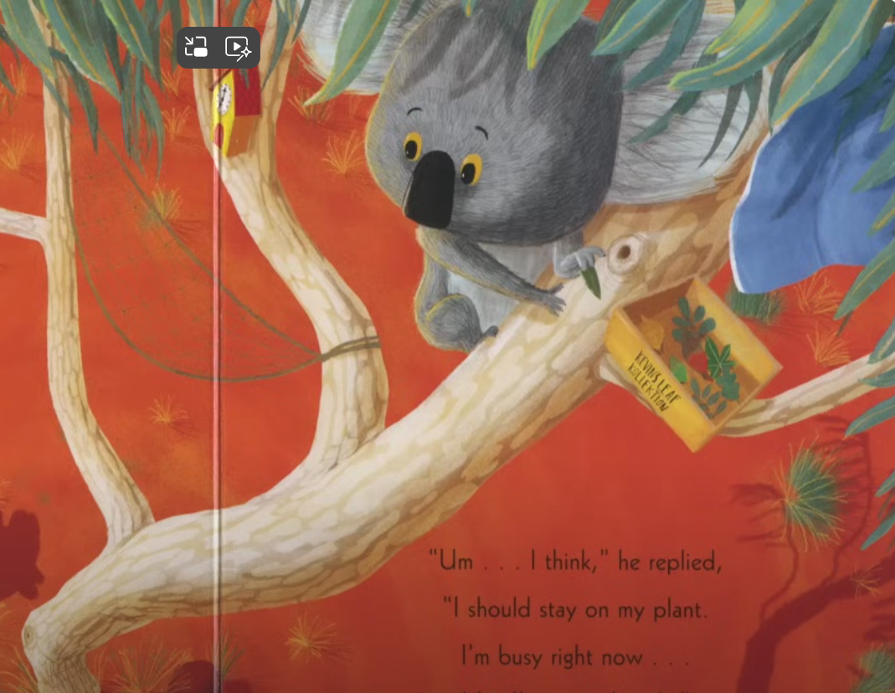  Label objects in his tree  Thursday  Cut out Koala and stick onto speech bubble and write ‘I can …..’  . | Based on –  Monday  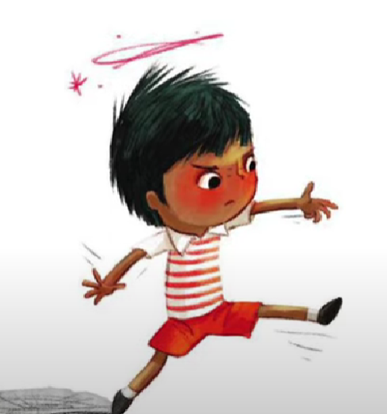  Cut out Ravi and make his roar appear  Tuesday  What made Ravi cross? Lael pictures – no ice cream, couldn’t reach monkey bars etc  Wednesday  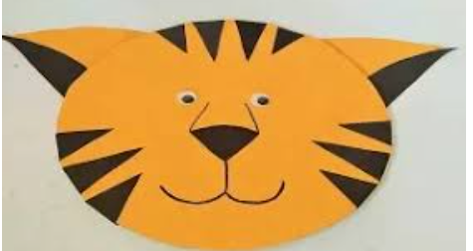  Thursday  What makes you cross?
 | PSHE |   Bouncing back when things go wrong | Yes, I can | Healthy eating | My healthy mind | Move your body
Specific Areas | Literacy reading/ understanding | Story time focus -  Storytelling and recall  Responds to ‘who’, ‘where’ ‘what’ and ‘when’ questions linked to text and illustrations. | Story time focus -  Storytelling and recall  Responds to ‘who’, ‘where’ ‘what’ and ‘when’ questions linked to text and illustrations. | Story time focus –  Prediction  Answers questions about why or how things have happened. | Story time focus –  Prediction  Answers questions about why or how things have happened. | Story time focus -  Vocab  Begins to use modelled vocabulary during role play and small world.
 | Phonics | RWinc groups linked to individual progress within the programme. | RWinc groups linked to individual progress within the programme. | RWinc groups linked to individual progress within the programme. | RWinc groups linked to individual progress within the programme. | RWinc groups linked to individual progress within the programme.
 | Literacy writing | - Daily name writing  - Finger fit – initial sounds/cvc words  - Handwriting and letter formation  - Writing opportunities within CP | - Daily name writing  - Finger fit – initial sounds/cvc words  - Handwriting and letter formation  - Writing opportunities within CP | - Daily name writing  - Finger fit – initial sounds/cvc words  - Handwriting and letter formation  - Writing opportunities within CP | - Daily name writing  - Finger fit – initial sounds/cvc words  - Handwriting and letter formation  - Writing opportunities within CP | - Daily name writing  - Finger fit – initial sounds/cvc words  - Handwriting and letter formation  - Writing opportunities within CP
 | Maths | To 20 and beyond | To 20 and beyond | How many now? | Manipulate, compose and decompose |  |  | Manipulate, compose and decompose
 | Maths Fluency | Patterns in numbers to 10 | Number facts fluency  Subitising 1-5 | Number facts fluency  Subitising 1-5 | Number facts fluency  Make and break 5 |  |  | Number facts fluency  Make and break 5
 | Maths book of the week | 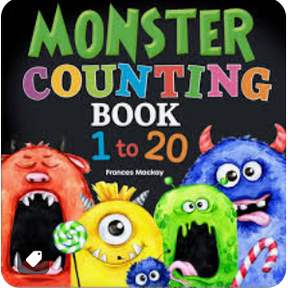 | 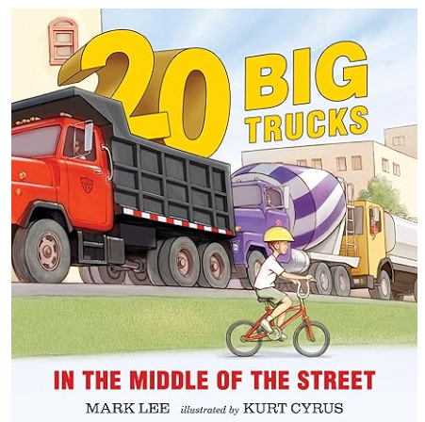 | 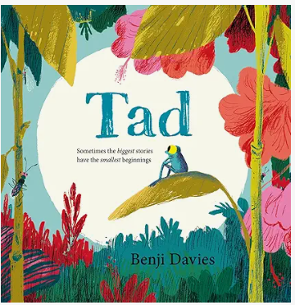 | 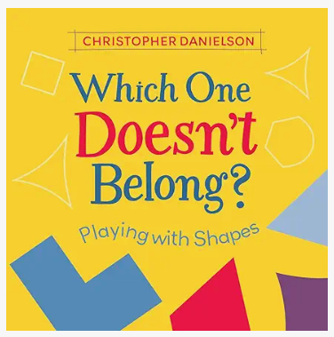 |  |  | 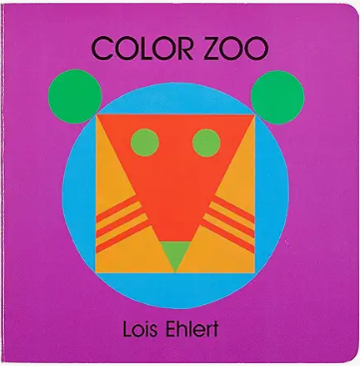
 | Understanding of the world | Past and present  Begin to develop an awareness of the past beyond living memory through books and stories  People and communities (RE)  Know that some stories are special and why.  Know that the bible is a special book for Christians and hear a range of these (weekly ‘Open the book’ assemblies)  Key text  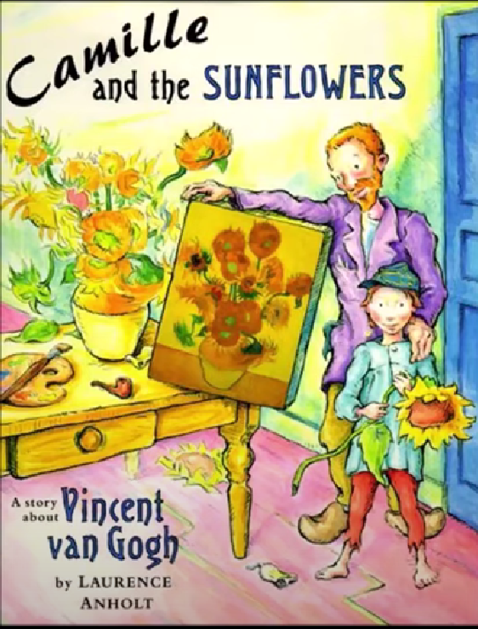 | The natural world  Knows that the length of day and night changes depending on the season  Past and present  Uses vocabulary for time-old, new, now, then  Key Text  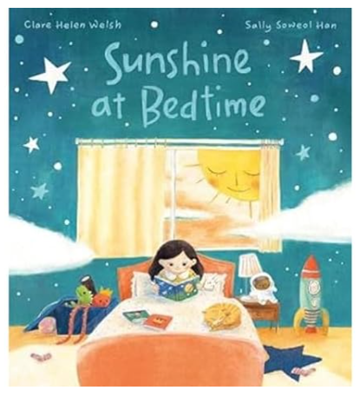 | Past and present  Know there are 7 days in a week and the names and order of these  People and communities (RE)  Know that our differences make us special and unique  Key Text  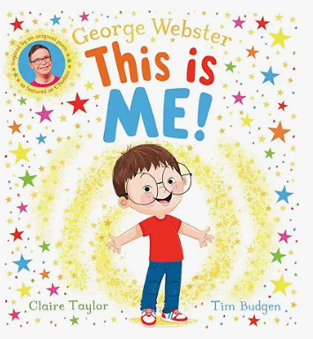 | The natural world  Can talk about different habitats and why they are good for certain living things (e.g. Hedgehogs, birds, foxes, minibeasts)  People and communities (RE)  Know that we belong to lots of different communities  Key Text  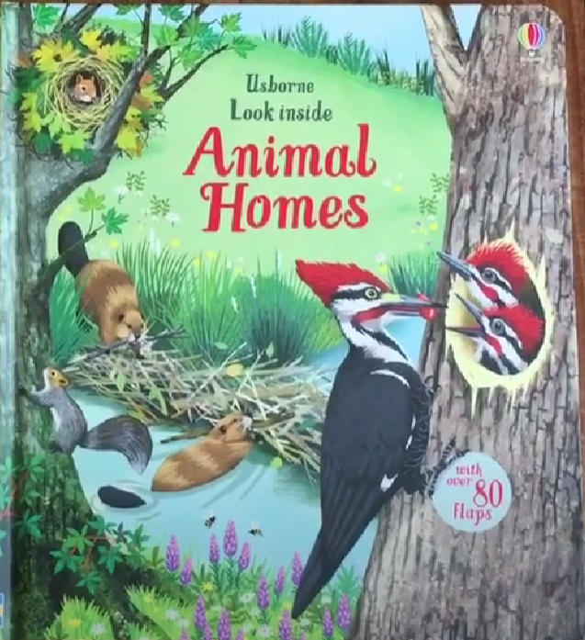 |  |  | The natural world  Knows names for baby animals and can match these to their adult.  Looks at animal key stages of development from birth to adult  People and communities (RE)  Know that people belong to different faith communities and know what faith communities some of us belong to  Key Text  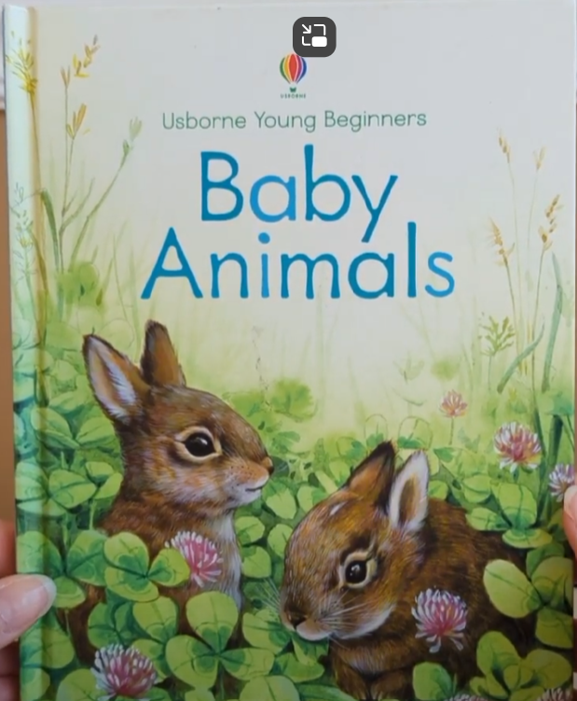
 | Expressive Arts and Design | Creating with materials  Artist of the term – Michelle Reader  Junk modelling material animals  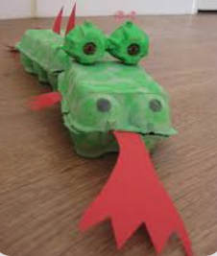  Singing/ music  Charanga – Big Bear Funk  Dancing – Giraffes can’t dance | Creating with materials  Artist of the term – Michelle Reader  Junk modelling material animals  Singing/ music  Charanga - Big Bear Funk  Dancing – Giraffes can’t dance | Creating with materials  Artist of the term – Michelle Reader  Clay animals  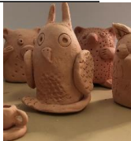  Singing/ music  Charanga – Big Bear Funk  Dancing – Giraffes can’t dance | Creating with materials  Artist of the term – Michelle Reader  Clay animals  Singing/music  Charanga – Big Bear Funk  Dancing – Giraffes can’t dance |  |  | Creating with materials  Artist of the term – Michelle Reader  Plasticine animals  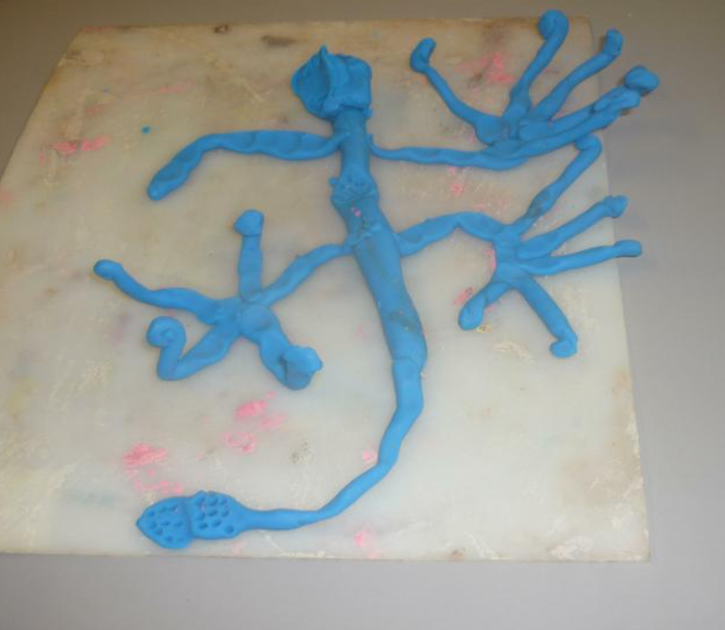  Singing/music  Charanga – Big Bear Funk  Dancing – Giraffes can’t dance

