 |  | Week 1 | Week 2 | Week 3 | Week 4 | Week 5 |  | Week 6
 |  | Direct teaching/ Adult led Activities ( details of opportunities in continuous provision on weekly overview)
 | Key text  Talk through stories | 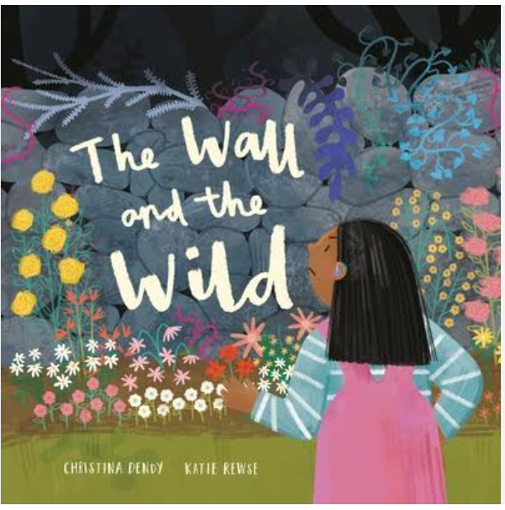 | 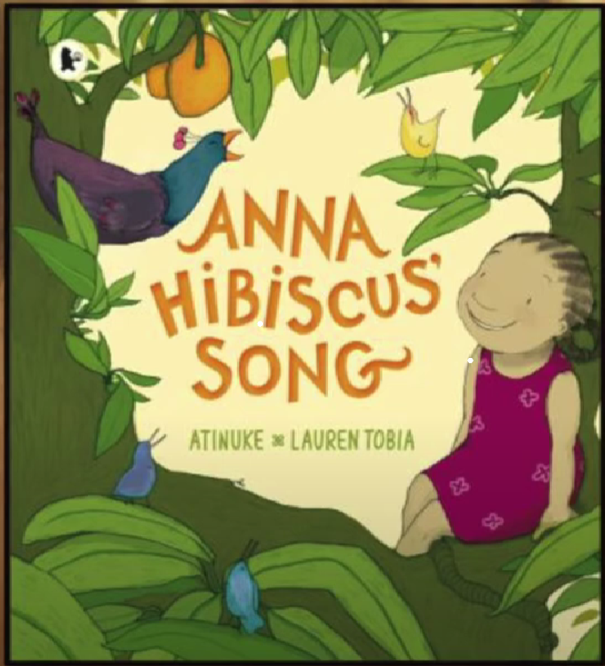 | 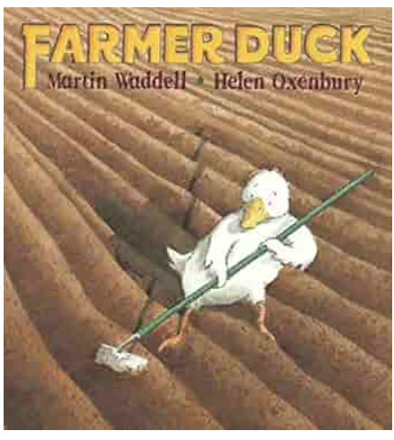 | 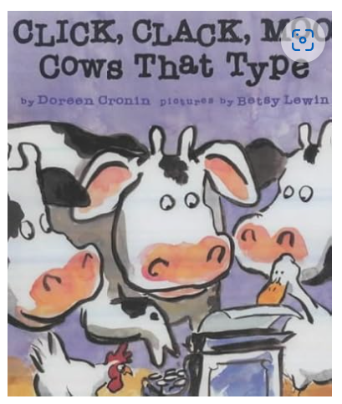 | 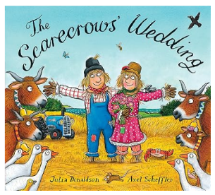 |  | 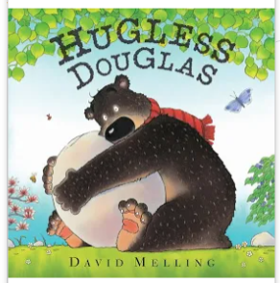
Prime areas | Communication  and Language | Oracy and listening  - Asking and answering questions  - Talking about our topic  - COOL TIME – what did my talk partner do?  - Talk through stories daily  - Daily Vocabulary work (Talk through stories)  - Re-tell a story to a small group using pictures of familiar book  - Using new Tier 2 and 3 vocab in CP and daily routines | Oracy and listening  - Asking and answering questions  - Talking about our topic  - COOL TIME – what did my talk partner do?  - Talk through stories daily  - Daily Vocabulary work (Talk through stories)  - Re-tell a story to a small group using pictures of familiar book  - Using new Tier 2 and 3 vocab in CP and daily routines | Oracy and listening  - Asking and answering questions  - Talking about our topic  - COOL TIME – what did my talk partner do?  - Talk through stories daily  - Daily Vocabulary work (Talk through stories)  - Re-tell a story to a small group using pictures of familiar book  - Using new Tier 2 and 3 vocab in CP and daily routines | Oracy and listening  - Asking and answering questions  - Talking about our topic  - COOL TIME – what did my talk partner do?  - Talk through stories daily  - Daily Vocabulary work (Talk through stories)  - Re-tell a story to a small group using pictures of familiar book  - Using new Tier 2 and 3 vocab in CP and daily routines | Oracy and listening  - Asking and answering questions  - Talking about our topic  - COOL TIME – what did my talk partner do?  - Talk through stories daily  - Daily Vocabulary work (Talk through stories)  - Re-tell a story to a small group using pictures of familiar book  - Using new Tier 2 and 3 vocab in CP and daily routines |  | Oracy and listening  - Asking and answering questions  - Talking about our topic  - COOL TIME – what did my talk partner do?  - Talk through stories daily  - Daily Vocabulary work (Talk through stories)  - Re-tell a story to a small group using pictures of familiar book  - Using new Tier 2 and 3 vocab in CP and daily routines
 | Nursery Rhyme | The animal fair | Cobbler cobbler | Days of the week | Busy Farmer Ben | Dr Foster went to Gloucester |  | Five little apples
 | Speaking | In COOl time model and support children to Plan – I will … I will go to… Because….  Ask What did you….? Why did you…? How did you…?
 | Physical Dev  Gross Motor  (in addition to PE in outdoor CP) | 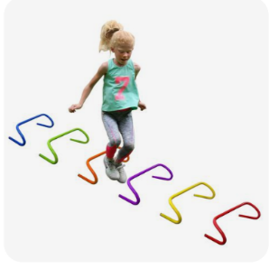Jumping over hurdles | Catch ball or balloon on upturned cone   | Obstacle course on stilts  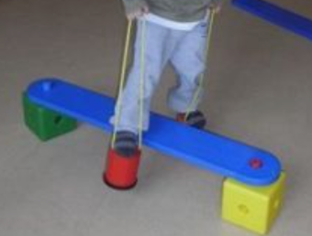 | Space hoppers  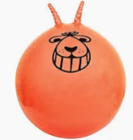 | Working together to carry a ball  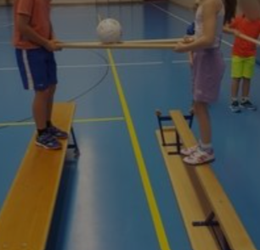 |  | Bats and balls  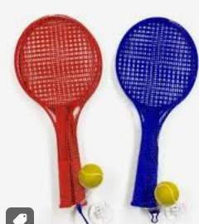
 | PE lessons | Gymnastics | Gymnastics | Gymnastics | Gymnastics | Gymnastics |  | Gymnastics
 | Fine motor skills  In CP | Stringing cheerios onto a pipe cleaner | Balance game ie…penguins or Jenga | Posting pom poms through a tube | Cutting long zig zag and spiral patterns | Sorting lentils, beans and seeds using tweezers |  | Stacking cups
 | Finger Fit – Fine motor skills and independent writing opportunity | Children to orally compose own sentences – adult to model back as complete sentence  Children work towards individual next steps in writing.
 |  | Based on – The wall and the wild  Monday  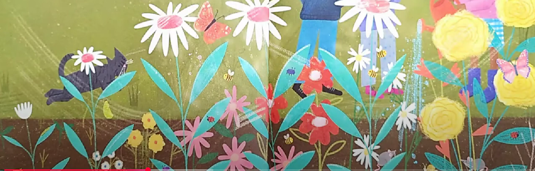  Cut out watering can and stick on shiny blue water.  Tuesday  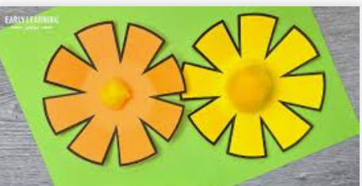  Cut out circle, snip edges, stick pom poms in middle and stalk.  Wednesday  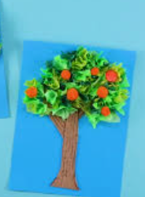  Tissue paper on tree.  Thursday  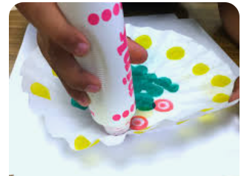  Butterfly with bingo dabbers. | Based on – Anna Hibiscus song  Monday  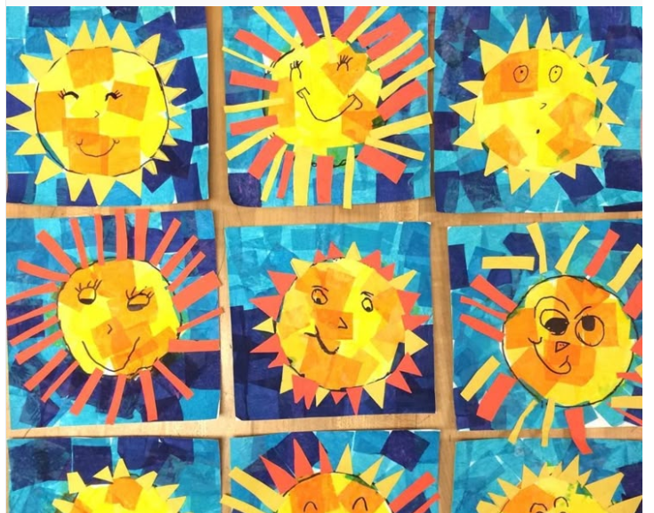  Sun with tissue paper and yellow strips.  Tuesday  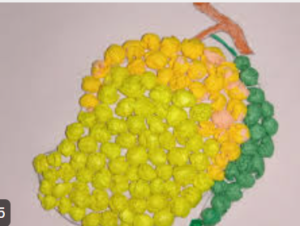  Mango with paper collage (bring in real mango to see)  Wednesday  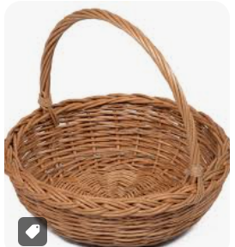  Cover basket template with strips of brown paper  Thursday  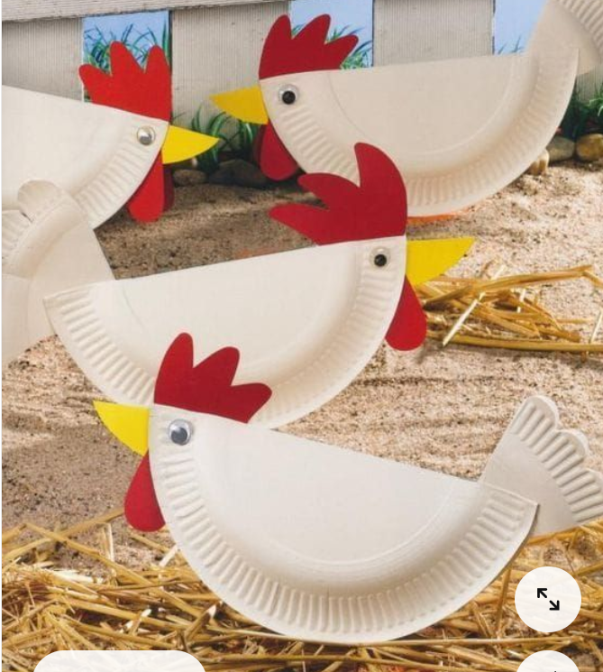 | Based on – Farmer Duck  Monday  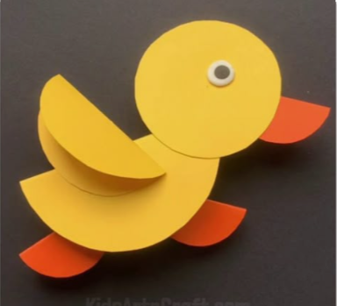  Tuesday  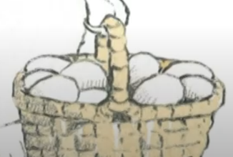  Cut out basket and stamp 5 egg shapes (potato?) into basket  Wednesday  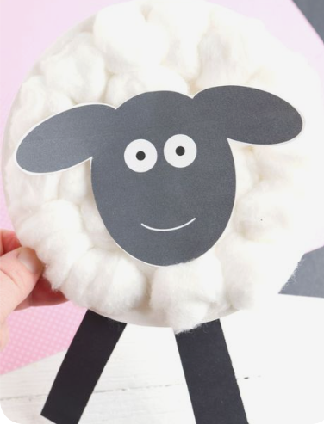  Thursday    Draw a picture on the card and write a thank you note inside, from the Farmer. | Based on – Click clack moo, cows that type  Monday  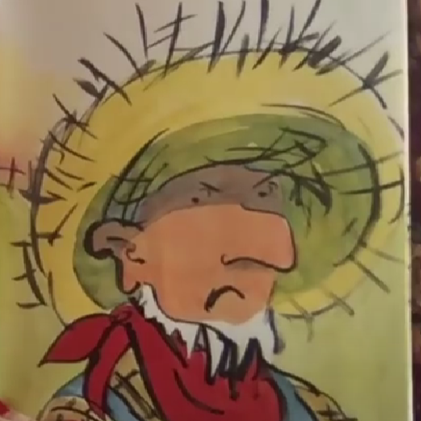  Tuesday  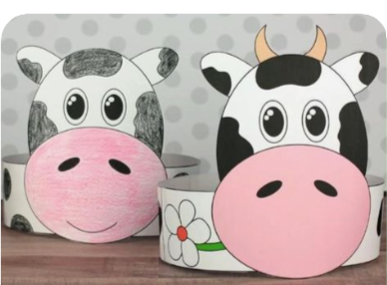  Cow mask  Wednesday  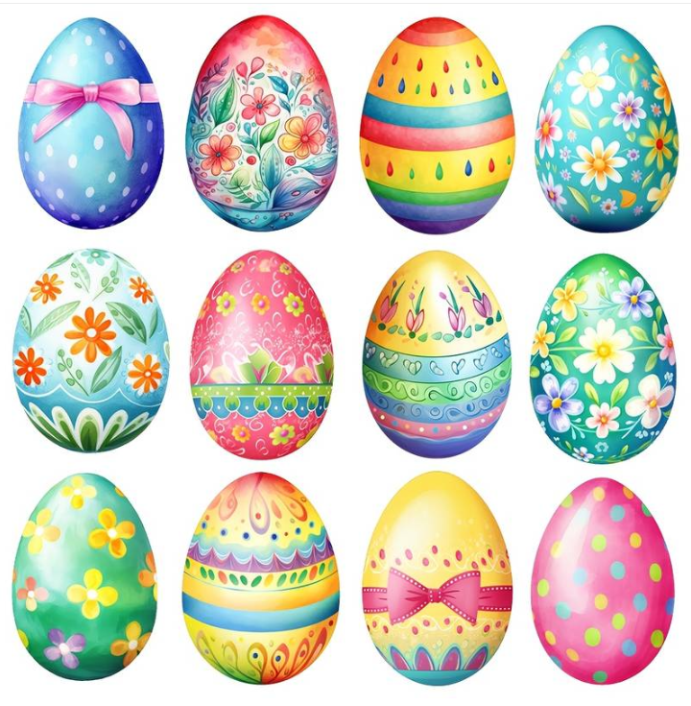  Decorate eggs  Thursday  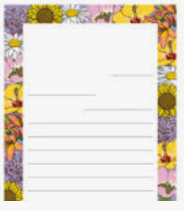  Letter template. Children to write what they would like ie...scooter, teddy. And draw pics. | Based on – The Scarecrow’s Wedding  Monday  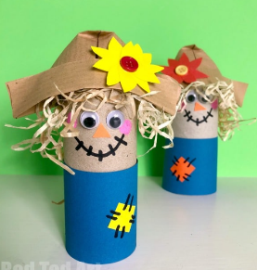  Tuesday    Wednesday  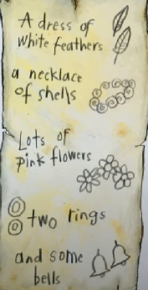  Cut out the pictures and write the accompanying words for the list.  Thursday  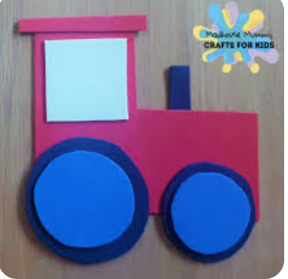Make a tractor with shapes. | Based on – Hugless  Douglas  Monday  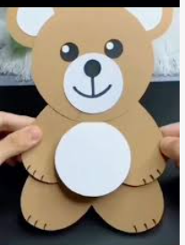  Bear with a red bow  Tuesday  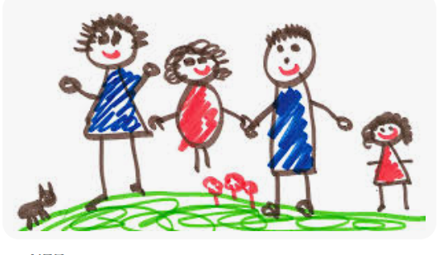  Themselves and who they love to cuddle…and label.  Wednesday  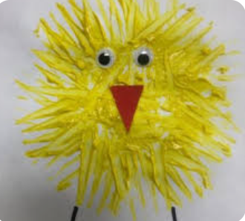  Easter card  Thursday  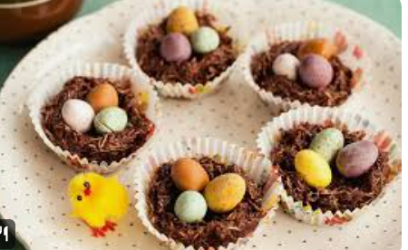  A chick and eggs
 | Personal social and emotional development |   Looking after my special people | Looking after my friends | Being helpful at home and caring for our classroom | Caring for our world | Looking after money - lesson 1: recognising, spending and using |  | Looking after money - lesson 2 saving it and keeping it safe
Specific Areas | Literacy reading/ understanding | Story time focus - Storytelling and recall  Sequences captions from a story | Story time focus -  Storytelling and recall  Sequences captions from a story | Story time focus –  Prediction  Comments and engages in conversation about the text, talking about what might happen next, linking to own experiences E.g. ‘I have a bike too. I went to the park. They might go to the park.’ | Story time focus –  Prediction  Comments and engages in conversation about the text, talking about what might happen next, linking to own experiences E.g. ‘I have a bike too. I went to the park. They might go to the park.’ | Story time focus -  Vocabulary  Begins to use modelled vocabulary during discussions around rhymes and poems, showing understanding of the vocabulary |  | Story time focus -  Vocabulary  Begins to use modelled vocabulary during discussions around rhymes and poems, showing understanding of the vocabulary
 | Literacy Phonics | RWinc groups linked to individual progress within the programme. | RWinc groups linked to individual progress within the programme. | RWinc groups linked to individual progress within the programme. | RWinc groups linked to individual progress within the programme. | RWinc groups linked to individual progress within the programme. |  | RWinc groups linked to individual progress within the programme.
 | Literacy writing | - Daily name writing  - Finger fit – initial sounds/cvc words  - Handwriting and letter formation  - Writing opportunities within CP | - Daily name writing  - Finger fit – initial sounds/cvc words  - Handwriting and letter formation  - Writing opportunities within CP | - Daily name writing  - Finger fit – initial sounds/cvc words  - Handwriting and letter formation  - Writing opportunities within CP | - Daily name writing  - Finger fit – initial sounds/cvc words  - Handwriting and letter formation  - Writing opportunities within CP | - Daily name writing  - Finger fit – initial sounds/cvc words  - Handwriting and letter formation  - Writing opportunities within CP |  | - Daily name writing  - Finger fit – initial sounds/cvc words  - Handwriting and letter formation  - Writing opportunities within CP
 | Maths white rose | Length, height and time | Building 9 and 10 | Building 9 and 10 | Building 9 and 10 | Explore 3D shapes |  | Explore 3D shapes
 | Maths Fluency  Number sense | Composition of 6 to 9 | Composition of 6 to 9 | Composition of 6 to 9 | Comparing quantities to 10 | Comparing quantities to 10 |  | Comparing quantities to 10
 | Maths book of the week | 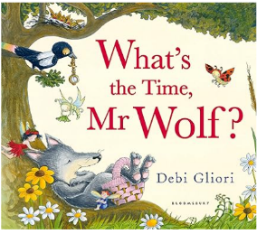 | 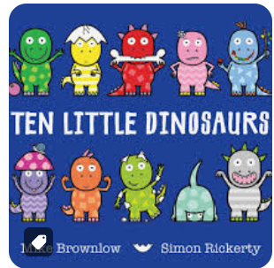 | 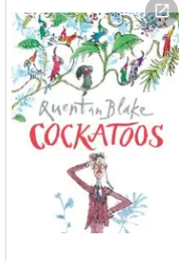 | 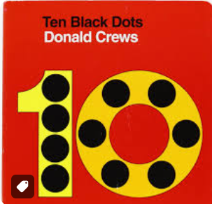 | 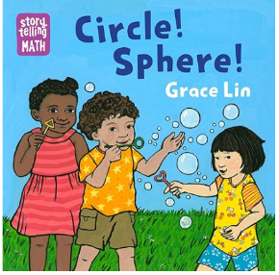 |  | 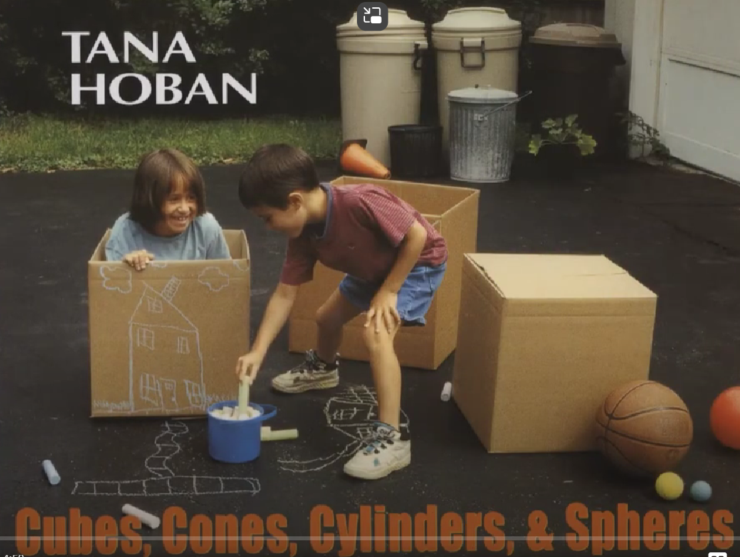
 | Understanding of the world | The natural world  Talks about changes that happen in the natural environment during Winter and Spring.  Past and present  Uses words such as baby, toddler, child, teenager, adult, and elderly to describe the age of people.  Key text  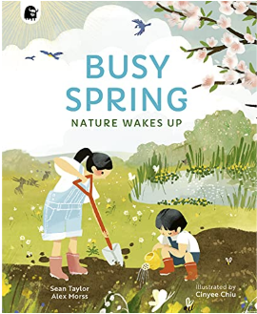  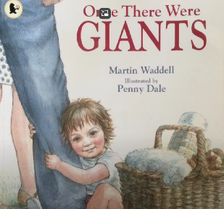 | The natural world  Observe and experience the wide variety of plants in our school environments.  Knows plants need water, warmth, and light to grow and survive  People and communities (RE)  Know how the daily lives of children in other countries is both similar and different from our own – link to RWinc story Anna Hibiscus’ song  Key Text  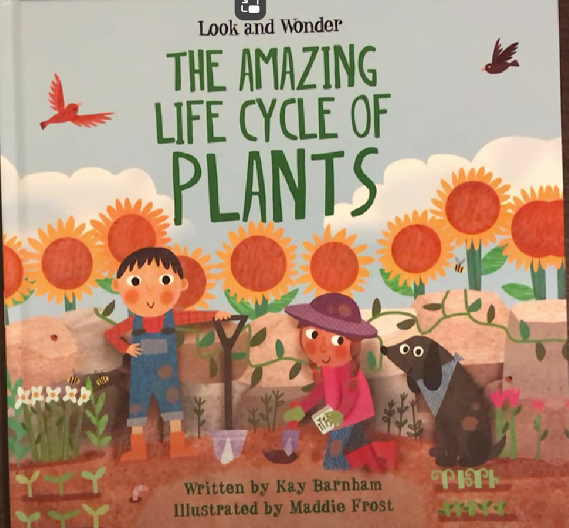 | The natural world  Knows most plants start growing from a seed or bulb by planting a range of flowers and vegetables  Past and present  Know there are 7 days in a week and the names and order of these  Start daily calendar – tell children day and month and sing the Days of the week song each day.  Key Text  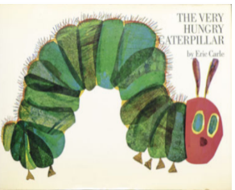 | The natural world  Know the terms seed bulb root stem leaf flower petal branch bark pollen trunk  Past and present  Knows how we will change as we grow up  People and communities (RE)  What is a church?  What is a Christening?  Visit a church  Key Text  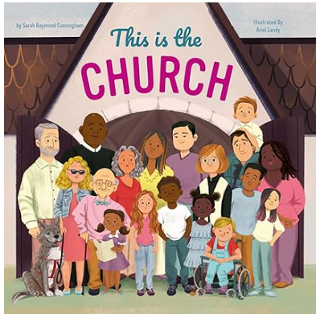 | The natural world  Identify, name observe and record a range of common minibeasts found in the school environment and discuss where they are commonly found.  People and communities (RE)  Understands that weddings can be very different in different cultures A Hindu wedding | Religious Studies - My Life, My Religion: Hinduism  My First Wedding - CBeebies  Key Text  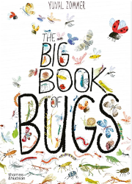 |  | The Natural world  Knows that living things do not stay the same over time (life cycles,  seasons, organic things decay over time).  Uses terms ‘egg’ and ‘chick ’ when observing the life cycle of a  chicken  Sew sunflower seeds for children to take home and have a competition.  People and communities (RE)  Understands why Christians celebrate Easter  Key Text  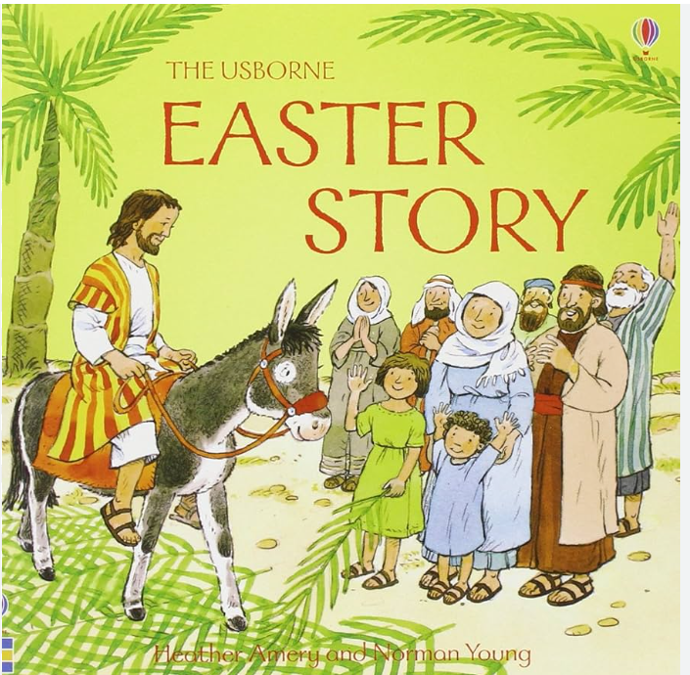
 | Expressive Arts and Design | Creating with materials  Artist of the term – Van Gogh  Observational drawings of flowers (maybe daffs, if no sunflowers) using paint and thin brushes.  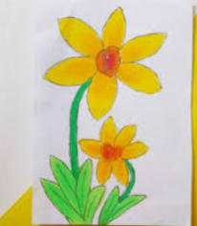  Singing/ music  Charanga – Our World  Dancing – Jack and the Beanstalk | Creating with materials  Artist of the term – Van Gogh  Observational drawings of flowers using pastels. Make a class display of flowers.  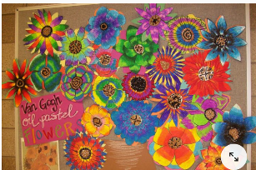  Singing/ music  Charanga - Our World  Dancing – Jack and the Beanstalk | Creating with materials  Artist of the term –  Van Gogh  Mix colours first and then apply with cotton bud.  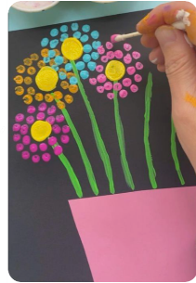  Singing/ music  Charanga – Our World  Dancing – Jack and the Beanstalk | Creating with materials  Artist of the term – Van Gogh  Printing with forks, toilet rolls etc...  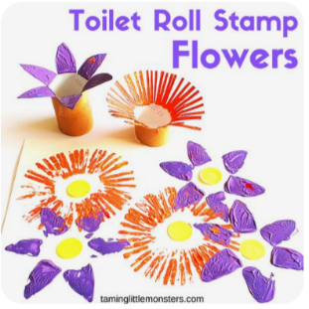  Singing/music  Charanga – Our World  Dancing – Jack and the Beanstalk | Creating with materials  Artist of the term – Van Gogh  Tissue paper and collage flowers.  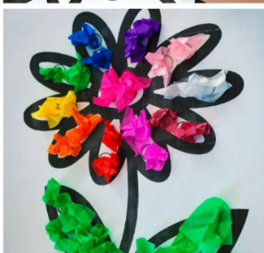  Singing/music  Charanga – Our World  Dancing – Jack and the Beanstalk |  | Creating with materials  Artist of the term – Van Gogh  Using cotton buds for middle of flower (or real sunflower seeds) and mixing different shades of yellow for petals.  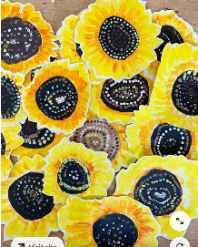  Singing/ music  Charanga – Our World  Dancing – Jack and the Beanstalk

