 | Week 1 | Week 2 | Week 3 | Week 4 | Week 5
Perfet sentence | Busy picture | Busy picture | Words containing “ar” | Words containing “or” | Words containing “air”
Maths | Measure using objects  Measure using CM  Heavier and Lighter  Measure Mass | Compare Mass  Full and Empty  Compare Volume  Measure Capacity | Compare Capacity  Count in 2’s | Count in 10’s  Count in 5’s | Recognise equal groups.  Make arrays  Make doubles
SEND Maths | Number bonds to 10  Addition- add together | Addition- add more  Find a part  Subtraction- find a part | Subtraction-take away/cross out  Subtraction- How many left?  Subtraction on a number line. | Recognise and name 2D shapes  Sort 3D shapes  Recognise and name 2D shapes  Sort 2D shapes | Patterns with 2D and 3D shapes.  Count within 20  Understand 10  Understand 11, 12 and 13
Fluency Bee | Comparison to 10 | Introduction to addition and subtraction | 1 more | 1 less | Add and subtract with 0
Literacy | Verb review | Verb review | What is a subject? | What is a subject? | What is a subject?
Talk through stories | George and the Dragon | George and the Dragon | Rhinocorn Rules | Rhinocorn Rules | The Koala who Could
SEND Literacy | Zig Zag Letters | Zig Zag Letters | Zig Zag Letters | Zig Zag Letters | Zig Zag Letters
Science | How can we sort all the animals in the zoo into the right places? | What is the difference between a vertebrate and an invertebrate? | Which families are invertebrates? | What are reptiles, fish and amphibians? | What is the difference between a bird and a mammal? | Now we know all about animal families can we sort all the zoo animals?
History | What is a castle and who​  built the first castles in England? | Why are castles often built on hills? | What are the features of a castle? (2 sessions) | What are the features of a castle? (2 sessions) | What was life like​  Inside castles? | Are castles still important today?
Art | How can we draw and accurate picture of a shell? | How can I add more detail to my drawing of a shell? | What is tone? | How can we use our tone paintings to create an installation? | What is a man-made sculpture? | What is a natural sculpture?
RE | What is the creation story? | How do the sun, moon, stars, land, and plants help us? | Who made the animals, birds, sea creatures, and people, and why are they special? | Why did God rest on the seventh day, and how can we thank Him for His creation? | What does the creation story teach us about God and how we should care for the world? | Can you retell the creation story and share what God made each day?
PSHE | I can eat a rainbow | Eat well | Wash up and brush up | Catch it, bin it, kill it | Learning to ride your bike
PE
Fine Motor | 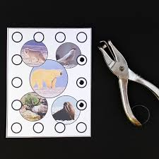 | Loom bands onto Lolly sticks  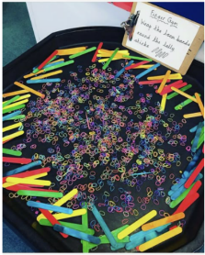 | 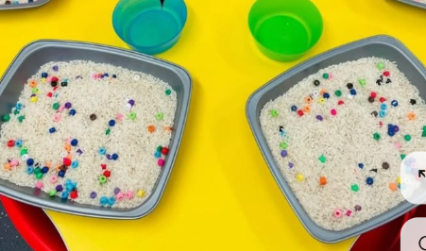  Picking beads out of rice against a timer? | Hole punch card  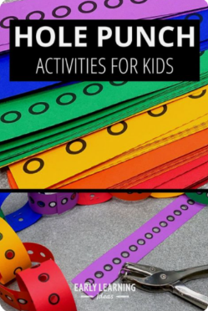 | Trim the hair (snip toilet roll tubes with faces)  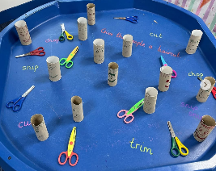
Light table | 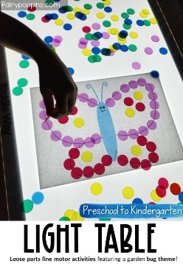 | 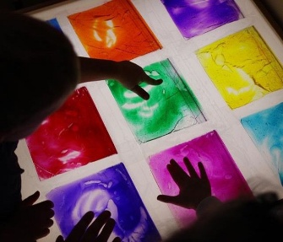  Oil paint in zip lock bag | 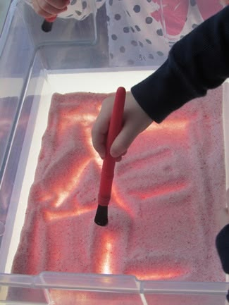  Glitter painting | 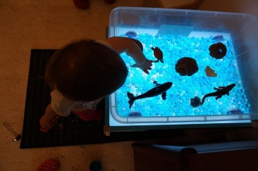  Animal shadows | Cars making patterns in sand  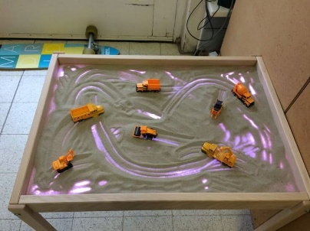
Junk | 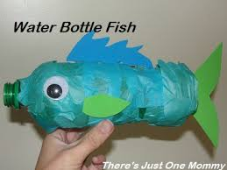  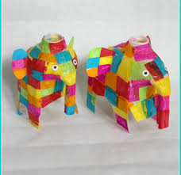 | Michelle Reader  Junk modelling material animals  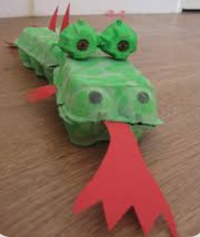 | Michelle Reader  Junk modelling material animals | 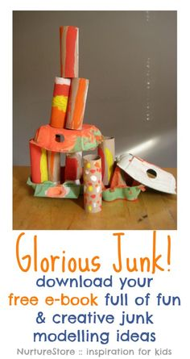  Build a junk castle | Build a junk castle
Role play | 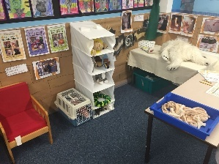 | Vets | Vets | Castle  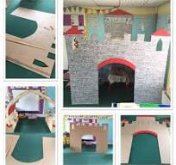 | Castle
Craft/Painting | 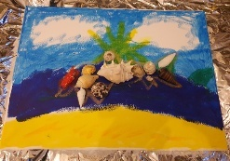 | Paper plate dragon  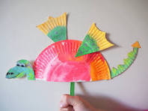 | 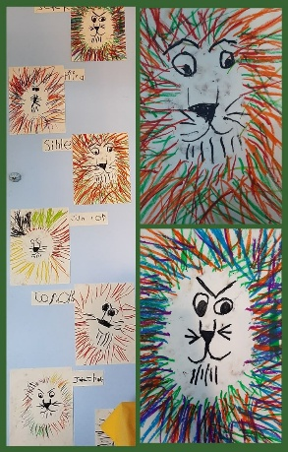  Oil pastel Lion | Castle Collage and brick printing  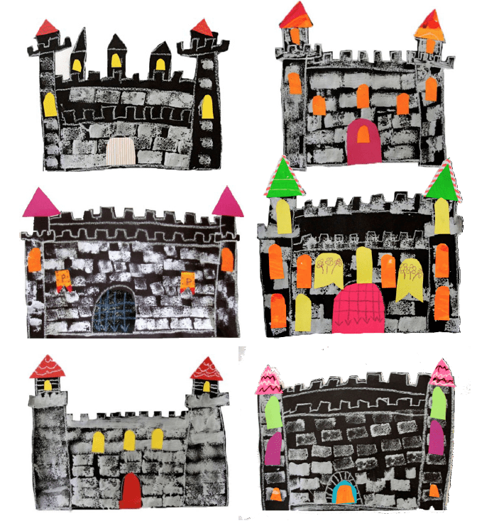 | Design a shield  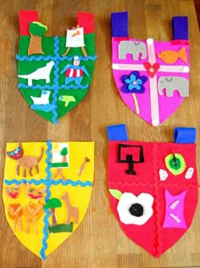
Sand | 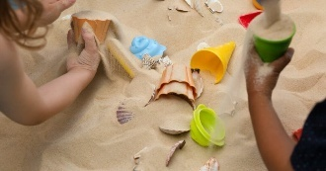 | 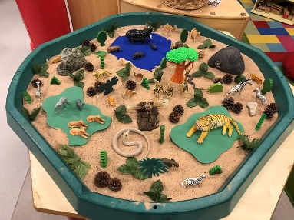  Safari Theme | Add a pond in a bowl with sea/pond animals and land animals.  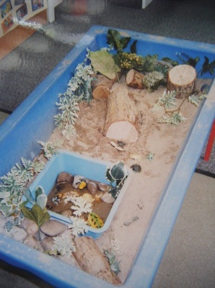 | Sand castles  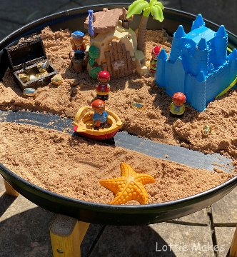 | Sand castles add shells  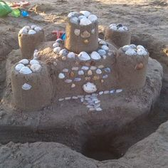
Water | 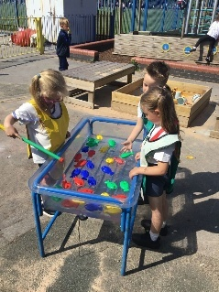 | Protect the ocean sea animals and rubbish with nets for fishing out.  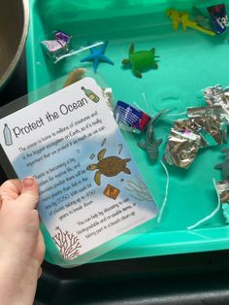 | Sea animals with sieves  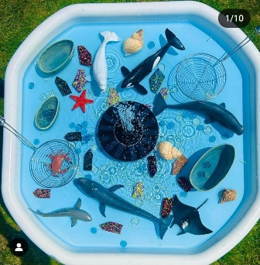 | Collect the sequins using tweezers  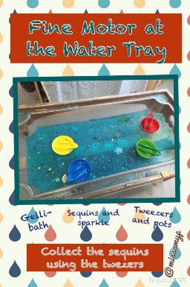 | Make bubbles  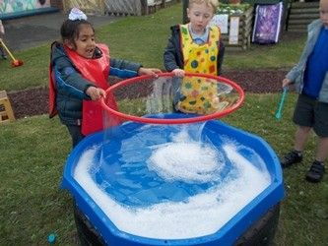
Tuff Tray | 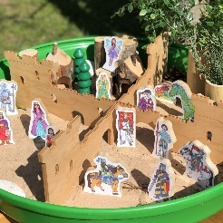 | Farm  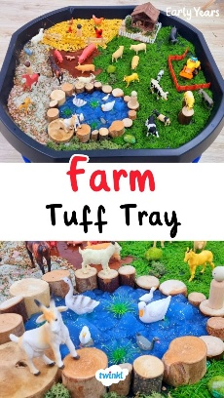 | 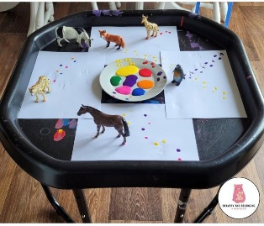  Animal footprints | Castle with moat  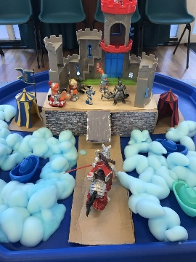 | 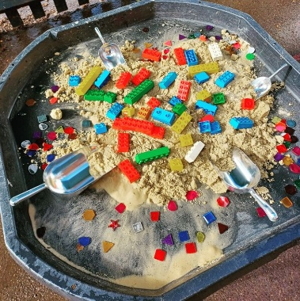  Build me a castle messy play

