 |  |  |  | Week 1 |  | Week 2 |  |  | Week 3 |  |  | Week 4 |  |  | Week 5 |  | Week 6 |  | Week 7
Key text  Talk through stories |  |  |  | 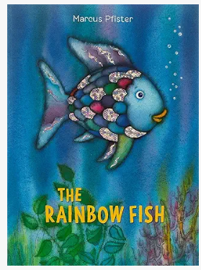 |  | 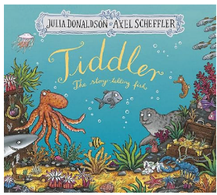 |  |  | 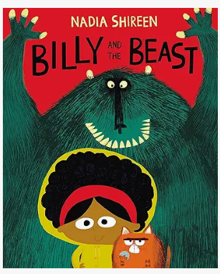 |  |  | 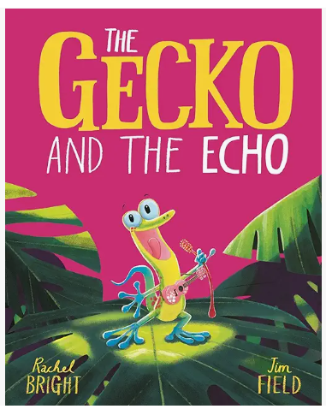 |  |  | 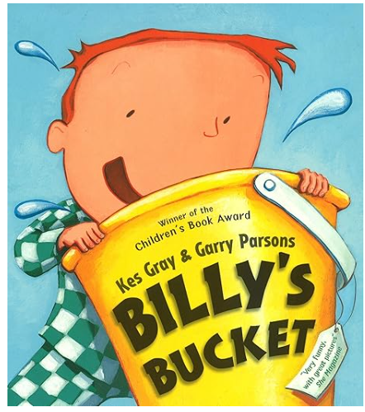 |  | 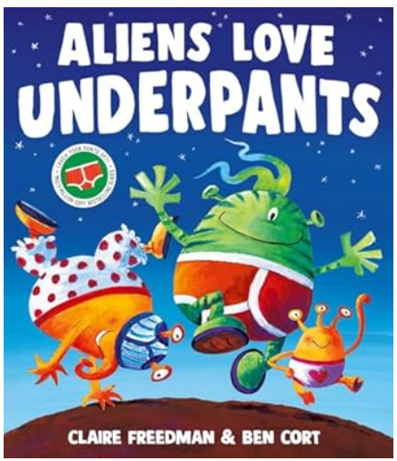 |  | 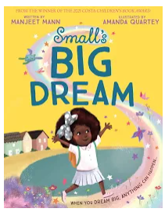
Prime areas |  | Communication  and Language |  | Oracy and listening  - Uses well-formed sentences  - Talks in the correct tense  - Understanding more complex language including prepositions, sequencing, time  - Retells how the story started, the main happening, and how it ended.  - Retells a story through roleplay, using some new vocabulary and some exact words from the text  - Can follow two-part instructions  Early Learning Goal  - Listen attentively and respond to what they hear with relevant questions, comments and actions when being read to and during whole class discussions and small group interactions  - Make comments about what they have heard and asks questions to clarify their understanding |  | Oracy and listening  - Uses well-formed sentences  - Talks in the correct tense  - Understanding more complex language including prepositions, sequencing, time  - Retells how the story started, the main happening, and how it ended.  - Retells a story through roleplay, using some new vocabulary and some exact words from the text  - Can follow two-part instructions  Early Learning Goal  - Listen attentively and respond to what they hear with relevant questions, comments and actions when being read to and during whole class discussions and small group interactions  - Make comments about what they have heard and asks questions to clarify their understanding |  |  | Oracy and listening  - Uses well-formed sentences  - Talks in the correct tense  - Understanding more complex language including prepositions, sequencing, time  - Retells how the story started, the main happening, and how it ended.  - Retells a story through roleplay, using some new vocabulary and some exact words from the text  - Can follow two-part instructions  Early Learning Goal  - Listen attentively and respond to what they hear with relevant questions, comments and actions when being read to and during whole class discussions and small group interactions  - Make comments about what they have heard and asks questions to clarify their understanding |  |  | Oracy and listening  - Uses well-formed sentences  - Talks in the correct tense  - Understanding more complex language including prepositions, sequencing, time  - Retells how the story started, the main happening, and how it ended.  - Retells a story through roleplay, using some new vocabulary and some exact words from the text  - Can follow two-part instructions  Early Learning Goal  - Listen attentively and respond to what they hear with relevant questions, comments and actions when being read to and during whole class discussions and small group interactions  - Make comments about what they have heard and asks questions to clarify their understanding |  |  | Oracy and listening  - Uses well-formed sentences  - Talks in the correct tense  - Understanding more complex language including prepositions, sequencing, time  - Retells how the story started, the main happening, and how it ended.  - Retells a story through roleplay, using some new vocabulary and some exact words from the text  - Can follow two-part instructions  Early Learning Goal  - Listen attentively and respond to what they hear with relevant questions, comments and actions when being read to and during whole class discussions and small group interactions  - Make comments about what they have heard and asks questions to clarify their understanding |  | Oracy and listening  - Uses well-formed sentences  - Talks in the correct tense  - Understanding more complex language including prepositions, sequencing, time  - Retells how the story started, the main happening, and how it ended.  - Retells a story through roleplay, using some new vocabulary and some exact words from the text  - Can follow two-part instructions  Early Learning Goal  - Listen attentively and respond to what they hear with relevant questions, comments and actions when being read to and during whole class discussions and small group interactions  - Make comments about what they have heard and asks questions to clarify their understanding |  | Oracy and listening  - Uses well-formed sentences  - Talks in the correct tense  - Understanding more complex language including prepositions, sequencing, time  - Retells how the story started, the main happening, and how it ended.  - Retells a story through roleplay, using some new vocabulary and some exact words from the text  - Can follow two-part instructions  Early Learning Goal  - Listen attentively and respond to what they hear with relevant questions, comments and actions when being read to and during whole class discussions and small group interactions  - Make comments about what they have heard and asks questions to clarify their understanding
 |  | Nursery Rhyme |  | Pat-a-cake |  | Yankee Doodle |  |  | 5 currant buns |  |  | Horsey horsey |  |  | Frere Jacques |  | Old King Cole |  | If you’re happy and you know it
 |  | Speaking |  | - Uses well-formed sentences  - Talks in the correct tense but may continue to have problems with irregular tenses and plurals, such as ‘runned’ for ‘ran’  - Begins to use modelled vocabulary during role play and small world.  - Responds to ‘who’, ‘where’ ‘what’ and ‘when’ questions and uses reasoning to justify their answers  Retells how the story started, the main happening, and how ended.  -Retells a story through roleplay, using some new vocabulary and some exact words from the text  - Understands humour  - Takes turns in much longer conversations  - Openly listens to other points of view  - Explains their point of view clearly when they disagree with an adult or a friend, using words as well as action |  | - Uses well-formed sentences  - Talks in the correct tense but may continue to have problems with irregular tenses and plurals, such as ‘runned’ for ‘ran’  - Begins to use modelled vocabulary during role play and small world.  - Responds to ‘who’, ‘where’ ‘what’ and ‘when’ questions and uses reasoning to justify their answers  Retells how the story started, the main happening, and how ended.  -Retells a story through roleplay, using some new vocabulary and some exact words from the text  - Understands humour  - Takes turns in much longer conversations  - Openly listens to other points of view  - Explains their point of view clearly when they disagree with an adult or a friend, using words as well as action |  |  | - Uses well-formed sentences  - Talks in the correct tense but may continue to have problems with irregular tenses and plurals, such as ‘runned’ for ‘ran’  - Begins to use modelled vocabulary during role play and small world.  - Responds to ‘who’, ‘where’ ‘what’ and ‘when’ questions and uses reasoning to justify their answers  Retells how the story started, the main happening, and how ended.  -Retells a story through roleplay, using some new vocabulary and some exact words from the text  - Understands humour  - Takes turns in much longer conversations  - Openly listens to other points of view  - Explains their point of view clearly when they disagree with an adult or a friend, using words as well as action |  |  | - Uses well-formed sentences  - Talks in the correct tense but may continue to have problems with irregular tenses and plurals, such as ‘runned’ for ‘ran’  - Begins to use modelled vocabulary during role play and small world.  - Responds to ‘who’, ‘where’ ‘what’ and ‘when’ questions and uses reasoning to justify their answers  Retells how the story started, the main happening, and how ended.  -Retells a story through roleplay, using some new vocabulary and some exact words from the text  - Understands humour  - Takes turns in much longer conversations  - Openly listens to other points of view  - Explains their point of view clearly when they disagree with an adult or a friend, using words as well as action |  |  | - Uses well-formed sentences  - Talks in the correct tense but may continue to have problems with irregular tenses and plurals, such as ‘runned’ for ‘ran’  - Begins to use modelled vocabulary during role play and small world.  - Responds to ‘who’, ‘where’ ‘what’ and ‘when’ questions and uses reasoning to justify their answers  Retells how the story started, the main happening, and how ended.  -Retells a story through roleplay, using some new vocabulary and some exact words from the text  - Understands humour  - Takes turns in much longer conversations  - Openly listens to other points of view  - Explains their point of view clearly when they disagree with an adult or a friend, using words as well as action |  | - Uses well-formed sentences  - Talks in the correct tense but may continue to have problems with irregular tenses and plurals, such as ‘runned’ for ‘ran’  - Begins to use modelled vocabulary during role play and small world.  - Responds to ‘who’, ‘where’ ‘what’ and ‘when’ questions and uses reasoning to justify their answers  Retells how the story started, the main happening, and how ended.  -Retells a story through roleplay, using some new vocabulary and some exact words from the text  - Understands humour  - Takes turns in much longer conversations  - Openly listens to other points of view  - Explains their point of view clearly when they disagree with an adult or a friend, using words as well as action |  | - Uses well-formed sentences  - Talks in the correct tense but may continue to have problems with irregular tenses and plurals, such as ‘runned’ for ‘ran’  - Begins to use modelled vocabulary during role play and small world.  - Responds to ‘who’, ‘where’ ‘what’ and ‘when’ questions and uses reasoning to justify their answers  Retells how the story started, the main happening, and how ended.  -Retells a story through roleplay, using some new vocabulary and some exact words from the text  - Understands humour  - Takes turns in much longer conversations  - Openly listens to other points of view  - Explains their point of view clearly when they disagree with an adult or a friend, using words as well as action
 |  | Physical Dev  Gross Motor |  | 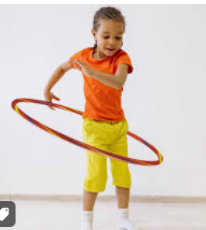  Hula hooping |  | 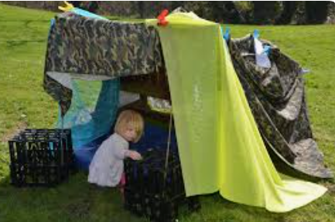  Build a den with large cardboard boxes |  |  | 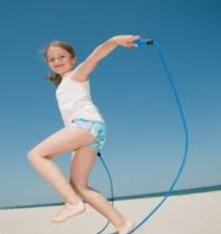  Skipping ropes |  |  | 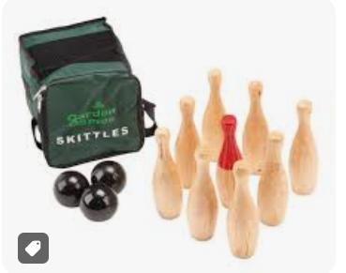  Skittles and keep score |  |  | 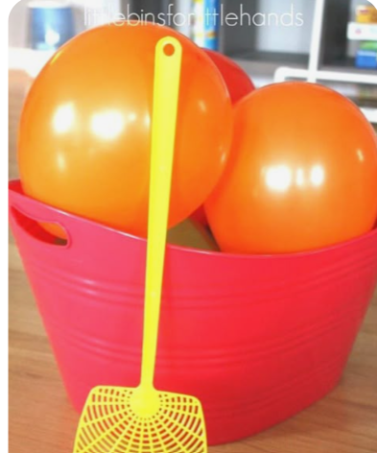  Balloon tennis |  | 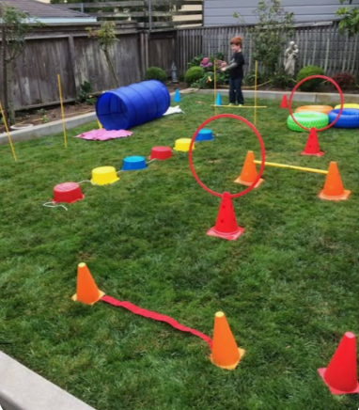  Obstacle course |  | 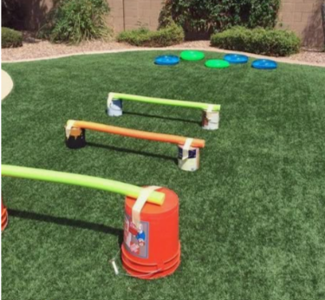  High jump
 |  | PE |  | Athletics |  | SPORTS DAY |  |  | Athletics |  |  | Athletics |  |  | Athletics |  | Athletics |  | Athletics
 |  | Fine motor skills |  | 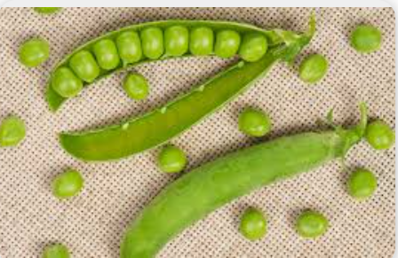  Shelling peas |  | 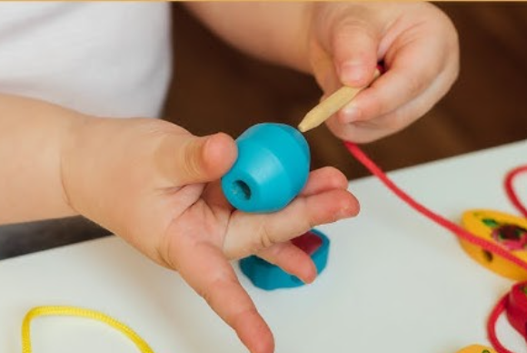  Threading |  |  | 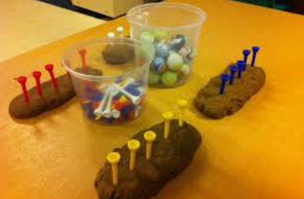  Balancing pom poms on golf tees |  |  | 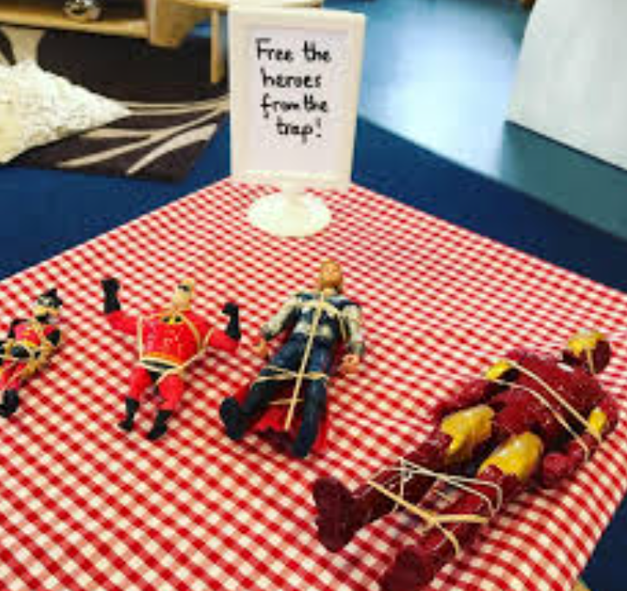  Free the heroes from the trap (elastic bands and superheroes) |  |  | 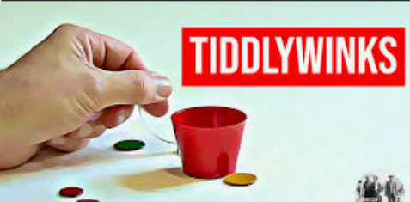 |  | 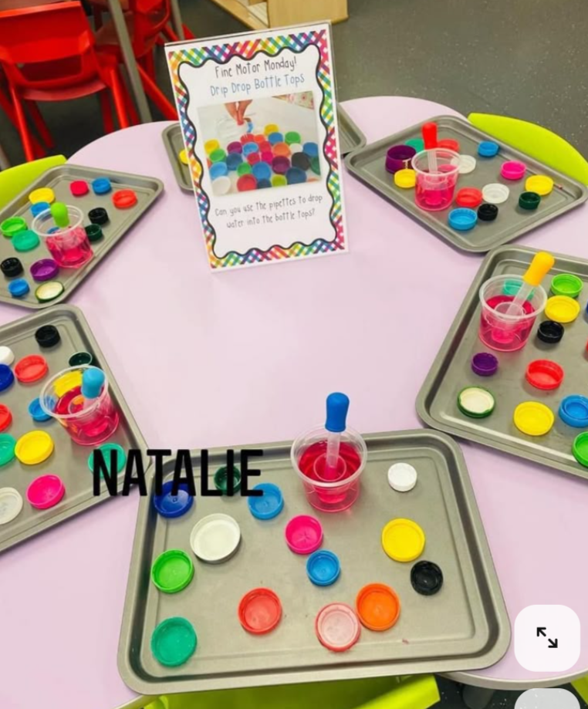  Use pipettes to drip water into bottle lids |  | 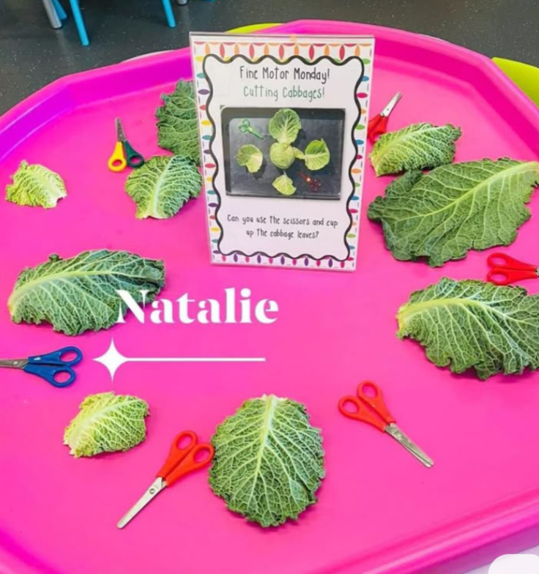  Cutting cabbage leaves with scissors
 |  | Finger Fit |  | Based on – Rainbow Fish  Monday  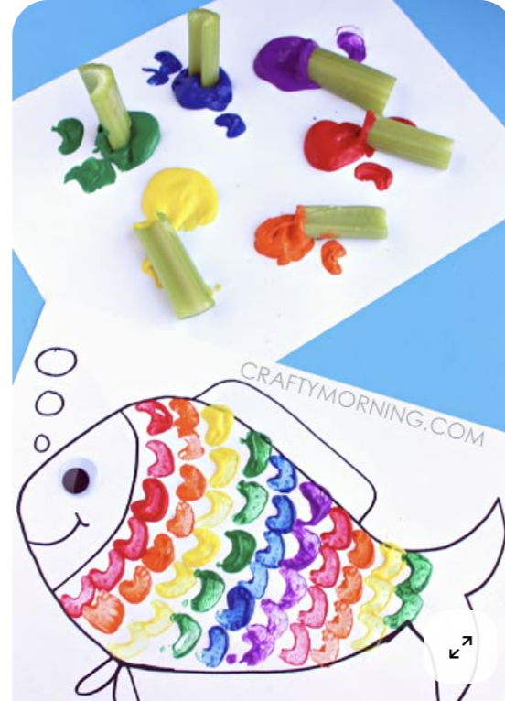  Tuesday  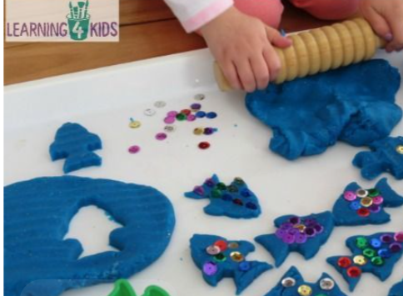  Wednesday  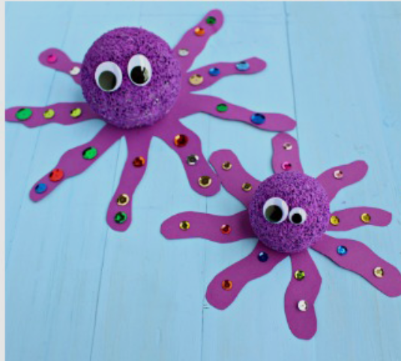  I have 8 legs  Thursday  Draw picture of themselves and their friend –I am …….. kind, helpful, share toys, make people laugh. |  | Based on – Tiddler  Monday  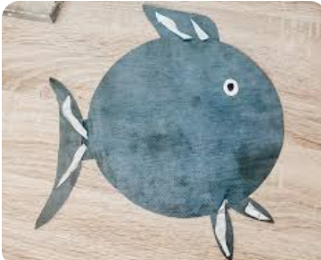  Tuesday  Children draw picture and write sentence as to why they were late. Sorry I was late….I was (visiting the moon etc)  Wednesday  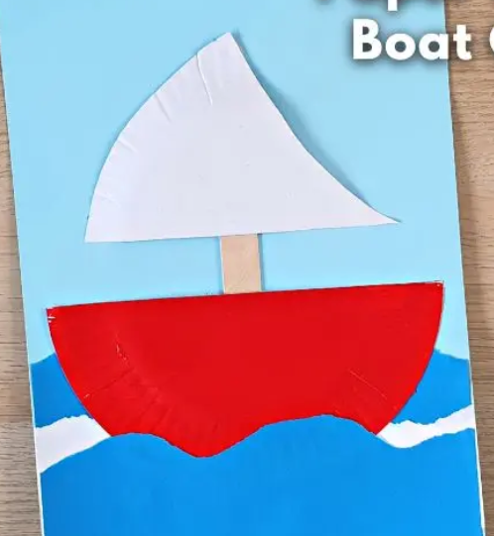  Draw a net and Tiddler.  Thursday  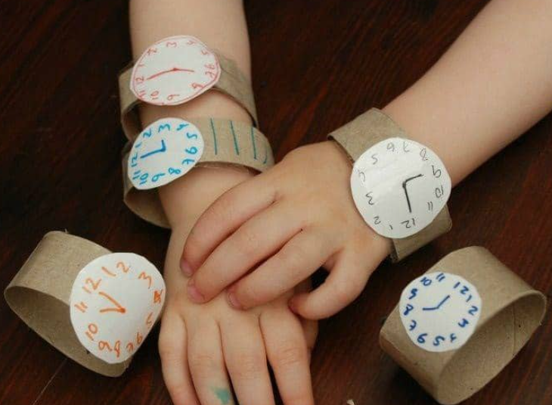 |  |  | Based on – Billy and the Beast  Monday  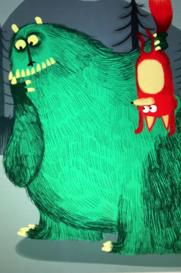  Paint and forks  Tuesday  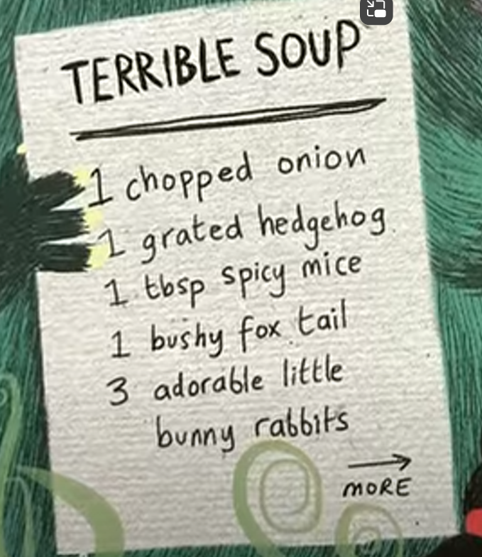  Make up recipe for terrible soup  Wednesday  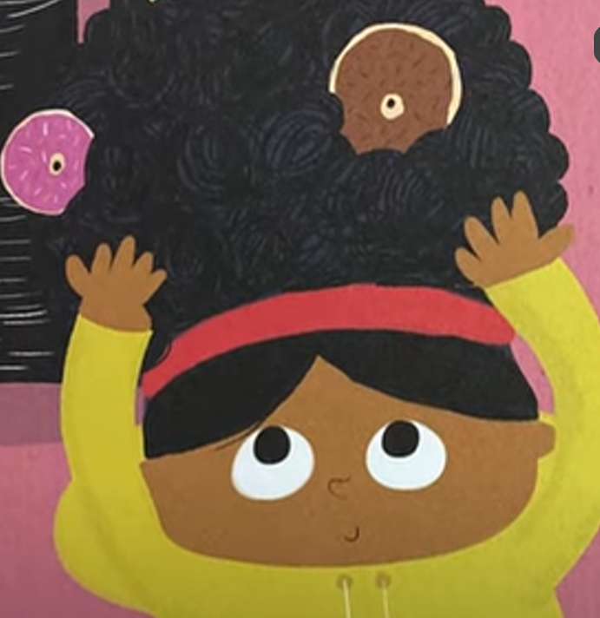  List 5 things you would put in your hair  Thursday  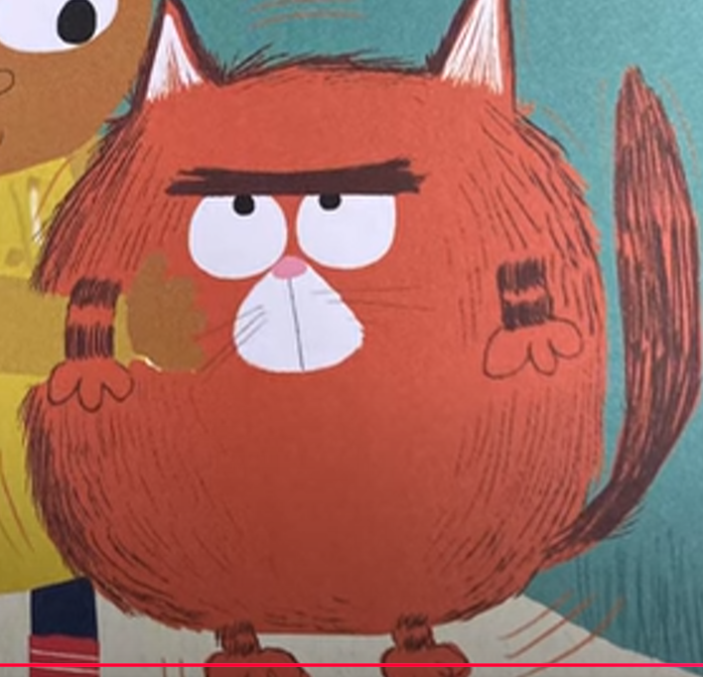 |  |  | Based on – Gecko and the echo (If going to beach….make a beach safety poster one day)  Monday  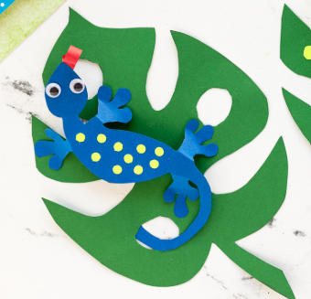Decorate gecko, cut out and stick on a leaf.  Tuesday  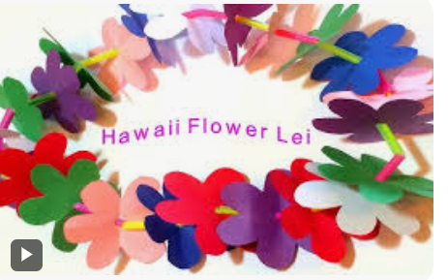  Make a flower lei  Wednesday  Goldy and a speech bubble  Thursday  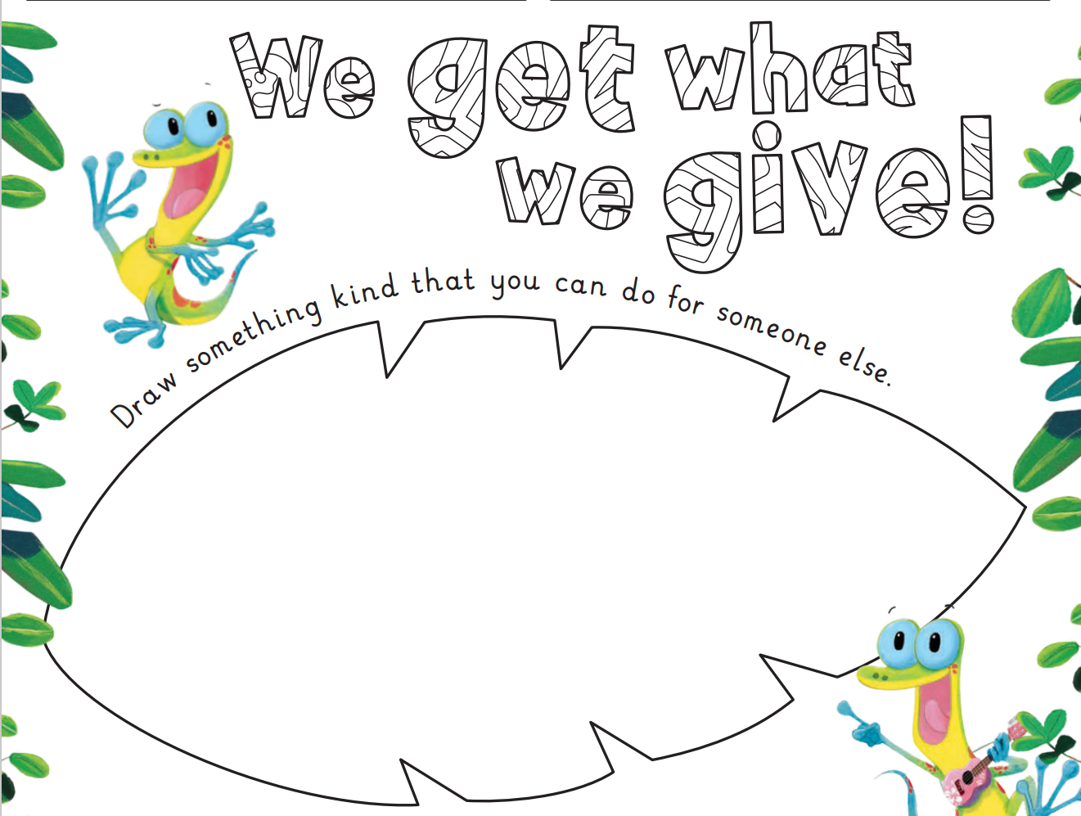  Draw something kind we could do for someone else |  |  | Based on – Big Sheep trip  Monday  Shadow puppet  Watch 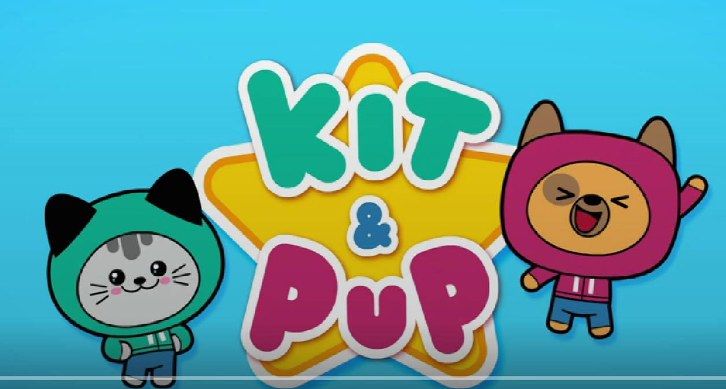  Make own puppet  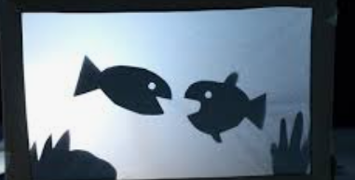  Under the sea creatures  Tuesday  Prepare for trip – list of what we will need to take  Wednesday  Big Sheep trip  Thursday  Caption for photo from trip |  | Based on – Aliens Love Underpants  Monday  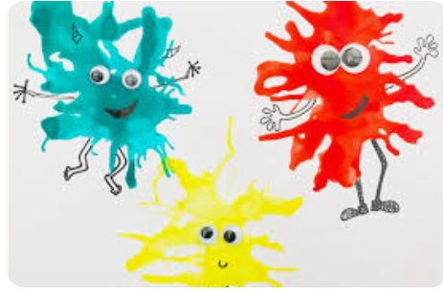  Make an alien with paint, straws and googly eyes  Tuesday  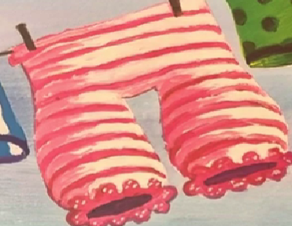  Design own underpants, cut out and put onto line  Wednesday  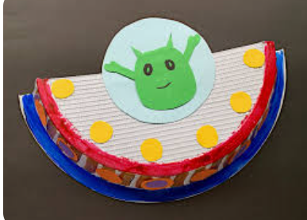  Thursday  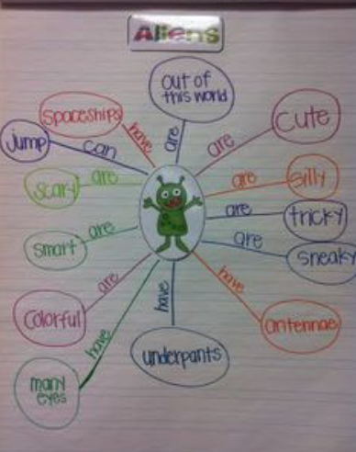 |  | Based on – Small’s Big Dream (Transition) Lewis Hamilton Reads 'Small's Big Dream' by Manjeet Mann | CBeebies Bedtime Stories  Make an ‘All about me’ book completing a page each day.  Monday  Picture of me and what I like doing  Tuesday  Who are your friends?  Wednesday  What makes you happy?  Thursday  What do you want to be when you grow up?
 |  | PSHE |  |   Seasons |  | Life stages – Plants, animals, humans. |  |  | Life stages – Human life stage – Who will I be? |  |  | Where do babies come from? |  |  | Getting bigger |  | Me and my body – girls and boys |  | Transition
 | Specific Areas |  | Literacy reading/ understanding |  | Story time focus - Storytelling and recall  - Responds to ‘who’, ‘where’ ‘what’ and ‘when’  - questions linked to text and illustrations.  - Retells how the story started, the main happening, and how ended.  - Retells a story through roleplay, using some new vocabulary and some exact words from the text  Early Learning Goals  - Demonstrate understanding of what has been read by retelling stories & narratives using own words and new vocabulary  - Anticipate key events in stories  - Use and understand recently introduced vocabulary during discussions about stories, non-fiction, rhymes and poems and during role play |  | Story time focus –  Storytelling and recall  - Responds to ‘who’, ‘where’ ‘what’ and ‘when’ questions linked to text and illustrations.  - Retells how the story started, the main happening, and how ended.  - Retells a story through roleplay, using some new vocabulary and some exact words from the text  Early Learning Goals  - Demonstrate understanding of what has been read by retelling stories & narratives using own words and new vocabulary  - Anticipate key events in stories  - Use and understand recently introduced vocabulary during discussions about stories, non-fiction, rhymes and poems and during role play |  |  | Story time focus –  Storytelling and recall  - Responds to ‘who’, ‘where’ ‘what’ and ‘when’ questions linked to text and illustrations.  - Retells how the story started, the main happening, and how ended.  - Retells a story through roleplay, using some new vocabulary and some exact words from the text  Early Learning Goals  - Demonstrate understanding of what has been read by retelling stories & narratives using own words and new vocabulary  - Anticipate key events in stories  - Use and understand recently introduced vocabulary during discussions about stories, non-fiction, rhymes and poems and during role play |  |  | Story time focus –  Prediction  - Answers questions about why or how things have happened.  - Predicts main happening in the text  Early Learning Goals  - Demonstrate understanding of what has been read by retelling stories & narratives using own words and new vocabulary  - Anticipate key events in stories  - Use and understand recently introduced vocabulary during discussions about stories, non-fiction, rhymes and poems and during role play |  | Story time focus -  Prediction  - Answers questions about why or how things have happened.  - Predicts main happening in the text  Early Learning Goals  - Demonstrate understanding of what has been read by retelling stories & narratives using own words and new vocabulary  - Anticipate key events in stories  - Use and understand recently introduced vocabulary during discussions about stories, non-fiction, rhymes and poems and during role play |  | Story time focus  Vocabulary  - Begins to use modelled vocabulary during role play and small world.  Early Learning Goals  - Demonstrate understanding of what has been read by retelling stories & narratives using own words and new vocabulary  - Anticipate key events in stories  - Use and understand recently introduced vocabulary during discussions about stories, non-fiction, rhymes and poems and during role play |  | Story time focus  Vocabulary  - Begins to use modelled vocabulary during role play and small world. Early Learning Goals  - Demonstrate understanding of what has been read by retelling stories & narratives using own words and new vocabulary  - Anticipate key events in stories  - Use and understand recently introduced vocabulary during discussions about stories, non-fiction, rhymes and poems and during role play
 |  |  | Phonics |  | RWinc groups linked to individual progress within the programme. |  | RWinc groups linked to individual progress within the programme. |  |  | RWinc groups linked to individual progress within the programme. |  |  | RWinc groups linked to individual progress within the programme. |  | RWinc groups linked to individual progress within the programme. |  | RWinc groups linked to individual progress within the programme. |  | RWinc groups linked to individual progress within the programme.
 |  |  | Literacy writing |  | -Picture stimulus – write letters from families and then a sentence (more more) about the picture.  -3 or 4 days of finger fit, 1 day of independent writing with picture stimulus.  -Simple sentence containing red word.  - Write own challenge sentence.  -Introduce special friends, CCVC CVCC words including word time 1.7 one, once, said, like  Writing Early Learning Goal  Forms most lower-case letters correctly, starting and finishing in the right place, going the right way round and correctly orientated. |  | -Picture stimulus – write letters from families and then a sentence (more more) about the picture.  -3 or 4 days of finger fit, 1 day of independent writing with picture stimulus.  -Simple sentence containing red word.  - Write own challenge sentence.  -Introduce special friends, CCVC CVCC words including word time 1.7 one, once, said, like  Writing Early Learning Goal  Forms most lower-case letters correctly, starting and finishing in the right place, going the right way round and correctly orientated. |  |  | -Picture stimulus – write letters from families and then a sentence (more more) about the picture.  -3 or 4 days of finger fit, 1 day of independent writing with picture stimulus.  -Simple sentence containing red word.  - Write own challenge sentence.  -Introduce special friends, CCVC CVCC words including word time 1.7 one, once, said, like  Writing Early Learning Goal  Forms most lower-case letters correctly, starting and finishing in the right place, going the right way round and correctly orientated. |  |  | -Picture stimulus – write letters from families and then a sentence (more more) about the picture.  -3 or 4 days of finger fit, 1 day of independent writing with picture stimulus.  -Simple sentence containing red word.  - Write own challenge sentence.  -Introduce special friends, CCVC CVCC words including word time 1.7 one, once, said, like  Writing Early Learning Goal  Forms most lower-case letters correctly, starting and finishing in the right place, going the right way round and correctly orientated. |  | -Picture stimulus – write letters from families and then a sentence (more more) about the picture.  -3 or 4 days of finger fit, 1 day of independent writing with picture stimulus.  -Simple sentence containing red word.  - Write own challenge sentence.  -Introduce special friends, CCVC CVCC words including word time 1.7 one, once, said, like  Writing Early Learning Goal  Forms most lower-case letters correctly, starting and finishing in the right place, going the right way round and correctly orientated. |  | -Picture stimulus – write letters from families and then a sentence (more more) about the picture.  -3 or 4 days of finger fit, 1 day of independent writing with picture stimulus.  -Simple sentence containing red word.  - Write own challenge sentence.  -Introduce special friends, CCVC CVCC words including word time 1.7 one, once, said, like  Writing Early Learning Goal  Forms most lower-case letters correctly, starting and finishing in the right place, going the right way round and correctly orientated. |  | -Picture stimulus – write letters from families and then a sentence (more more) about the picture.  -3 or 4 days of finger fit, 1 day of independent writing with picture stimulus.  -Simple sentence containing red word.  - Write own challenge sentence.  -Introduce special friends, CCVC CVCC words including word time 1.7 one, once, said, like  Writing Early Learning Goal  Forms most lower-case letters correctly, starting and finishing in the right place, going the right way round and correctly orientated.
 |  |  | Maths |  | Sharing and grouping |  |  | Visualise, build and map |  |  | Visualise, build and map |  |  | Visualise, build and map |  | Make connections |  | Recap and consolidate |  | Recap and consolidate
 |  |  | Maths Fluency |  | Number facts fluency  Subitising 1 to 5 |  |  | Number facts fluency  1 more, 1 less |  |  | Number facts fluency  1 more, 1 less |  |  | Number facts fluency  2 more, 2 less  Odd and even |  | Number facts fluency  2 more, 2 less  Odd and even |  | Recap and consolidate  Counting in 10’s and 2’s |  | Recap and consolidate  Counting in 10’s and 2’s
 |  |  | Maths book of the week |  | 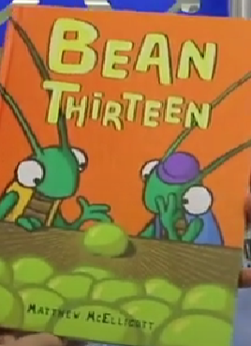 |  |  | 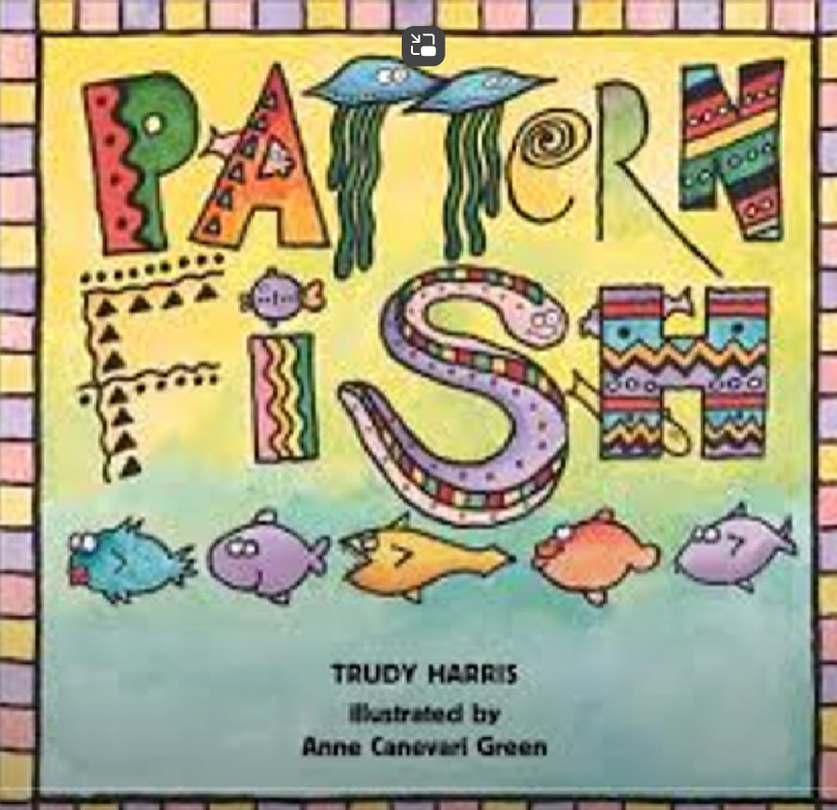 |  |  | 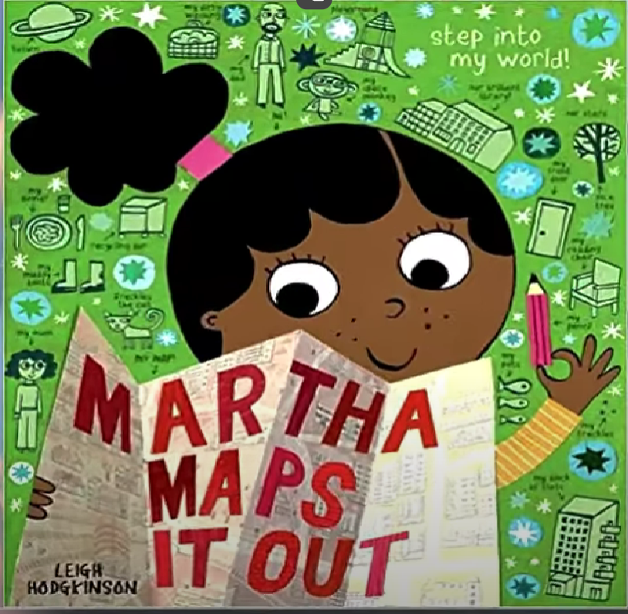 |  |  | 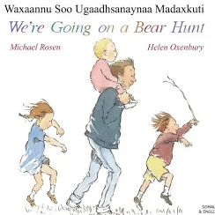 |  | 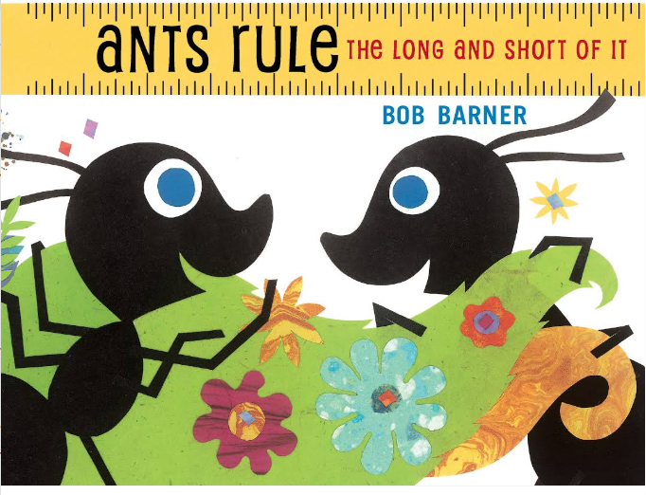 |  | 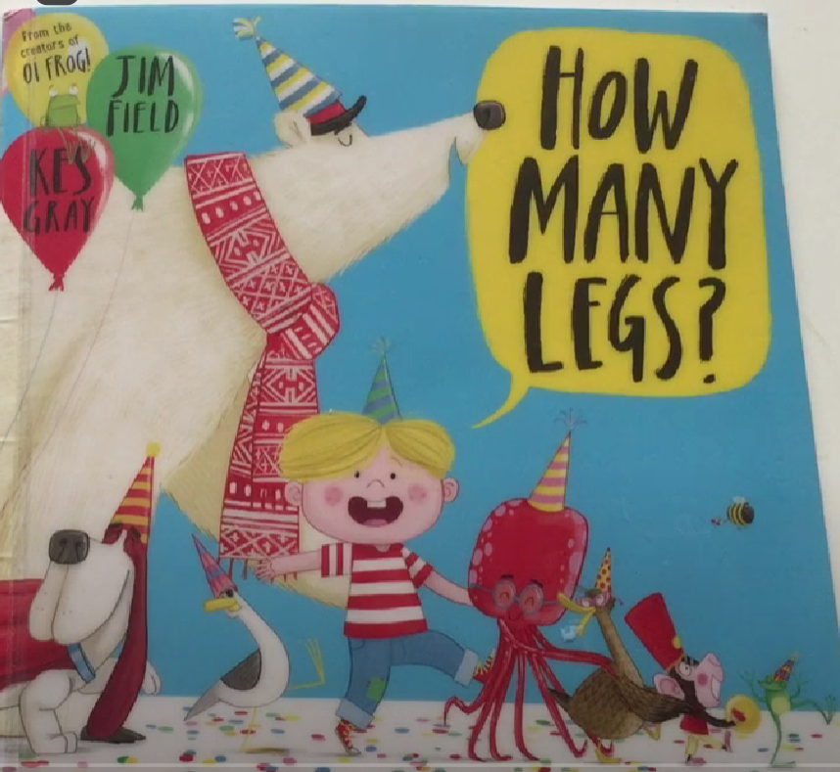 |  | 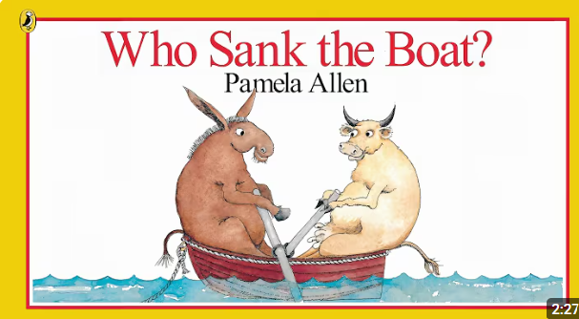
 |  |  | Understanding of the world |  | The natural world  Talks about changes that happen in the natural environment during Spring and Summer  Key text  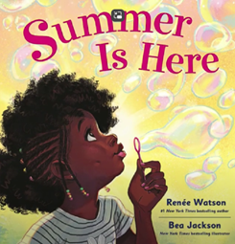 |  |  | The natural world  Can talk about underwater worlds and how these are habitats for different creatures  Key Text  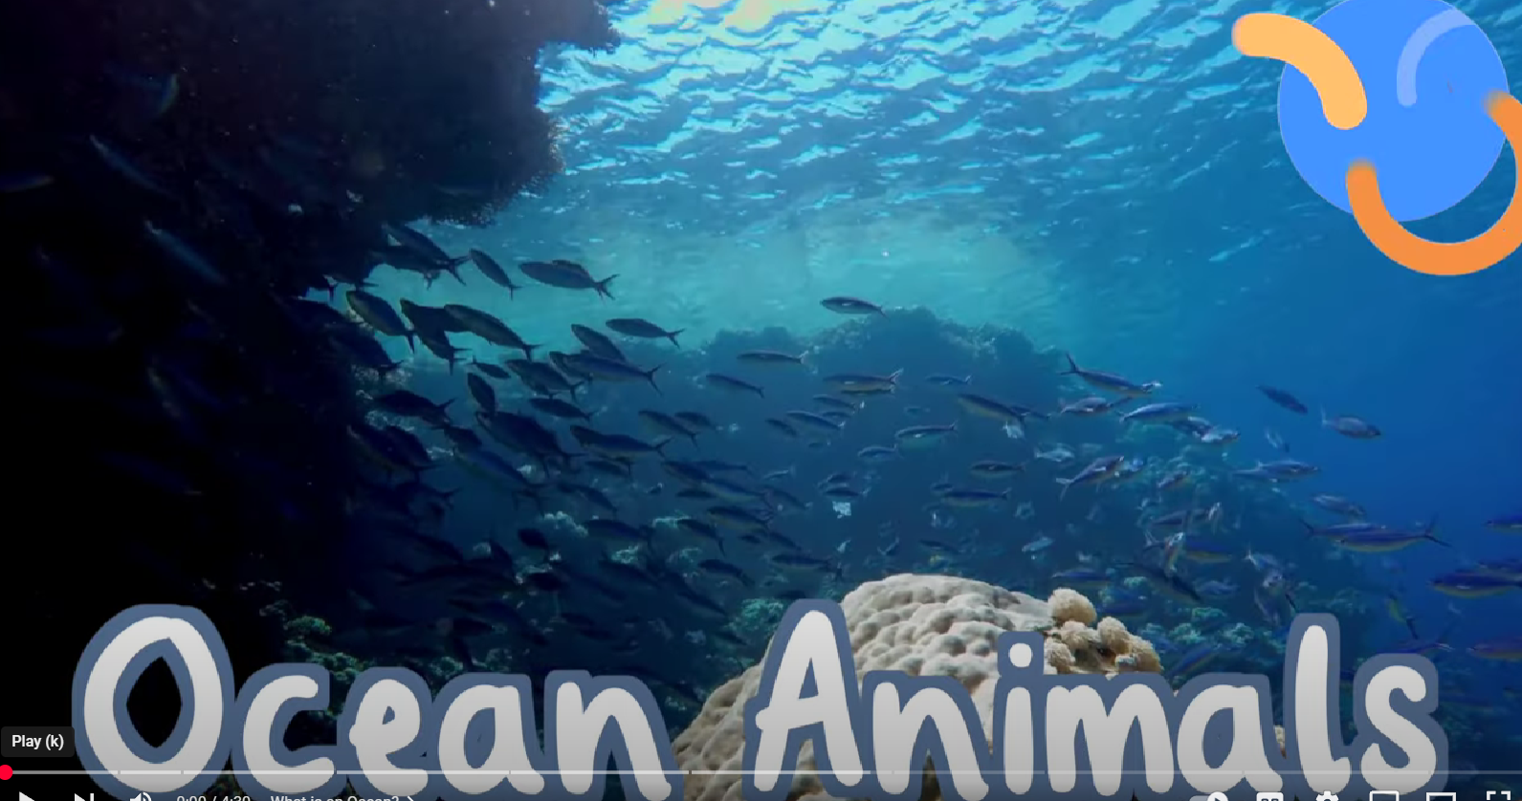  Twinkl Youtube  What Animals Live in the Ocean? | All About Sea Creatures for Kids |  |  | Past and present  Know there are 7 days in a week and the names and order of these  People and communities (RE)  Know that some of us have been abroad on holiday, they talk about their experiences  Key Text  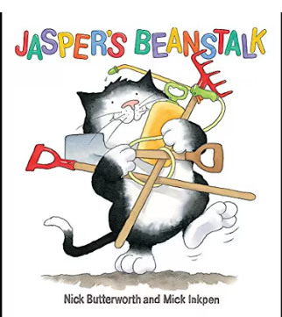 |  |  | The natural world  Understand that our beaches change depending on the tide  People and communities (RE) Understand that Bude is in Cornwall which is a small part of a country called England which is part of the United Kingdom  (possible beach trip)  Key Text  Bude, Cornwall, England, UK: Town & Beaches  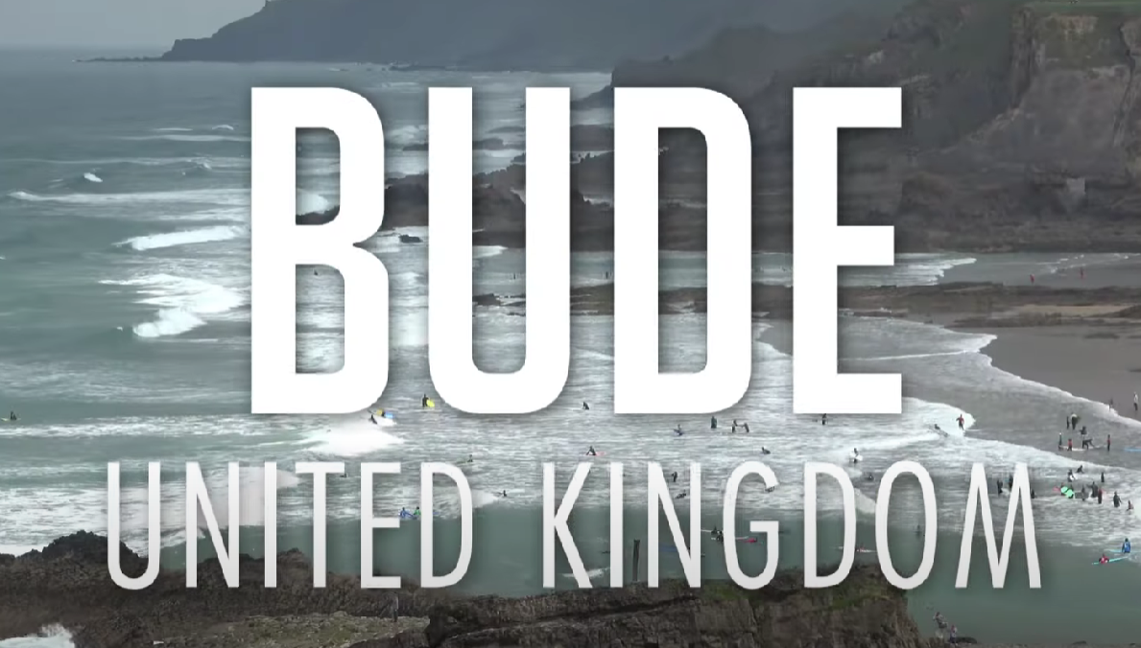 |  | The natural world  Observes and discusses natural processes such as objects casting a shadow, a magnet attracting an object and a boat floating on water.  People and communities (RE)  Big Sheep trip (2nd July)  Key Text  Light and dark |  | People and communities (RE)  Know what the UK looks like on a map and know where both Cornwall and Bude are on the map. Knows there are different countries in the world.  Know that there are lots of countries in the worlds and see this on a map  Key Text  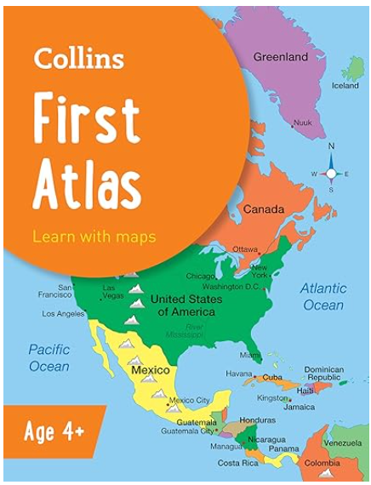 |  | Past and present  Uses vocabulary past, present, future (link to transition)  People and communities (RE)  Know that our differences make us special and unique (Link to transition into Year 1)  Key Text  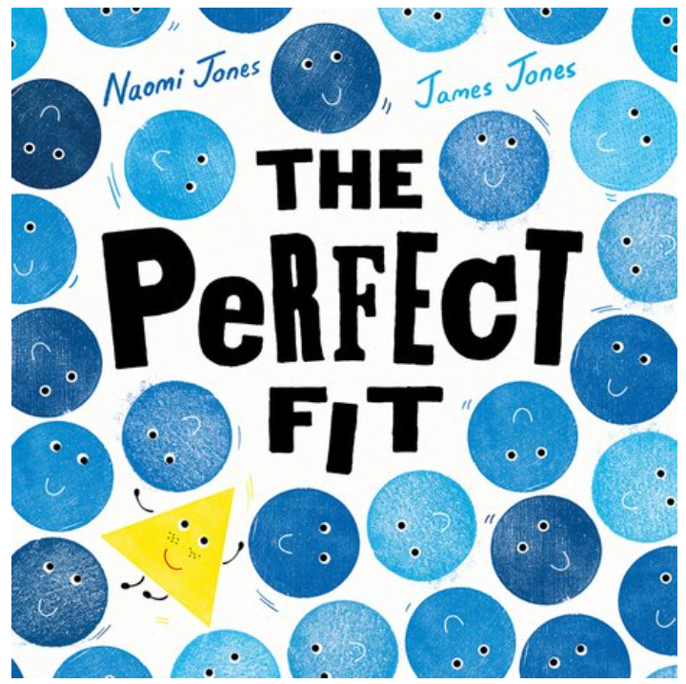
 |  |  | Expressive Arts and Design |  | Creating with materials  Artist of the term – TC trash art  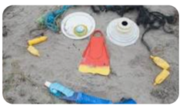  Use junk to create art sculptures  Singing/ music  Charanga – Reflect, rewind and replay  Dancing – Ocean Commotion |  |  | Creating with materials  Artist of the term – TC trash art  Use junk to create art sculptures  Singing/ music  Charanga - Reflect, rewind and replay  Dancing – Ocean Commotion |  |  | Creating with materials  Artist of the term – Andy Goldsworthy  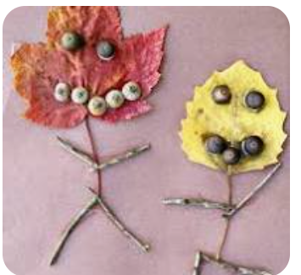  Transient art in the woods  Singing/ music  Charanga – Reflect, rewind and replay  Dancing – Ocean Commotion |  |  | Creating with materials  Artist of the term – Art on the beach.(Beach trip?) Transient Art using natural materials.  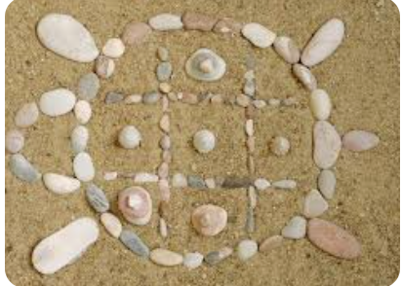  Singing/music  Charanga – Reflect, rewind and replay  Dancing – Ocean Commotion |  | Creating with materials  Artist of the term – Bonnie Steward  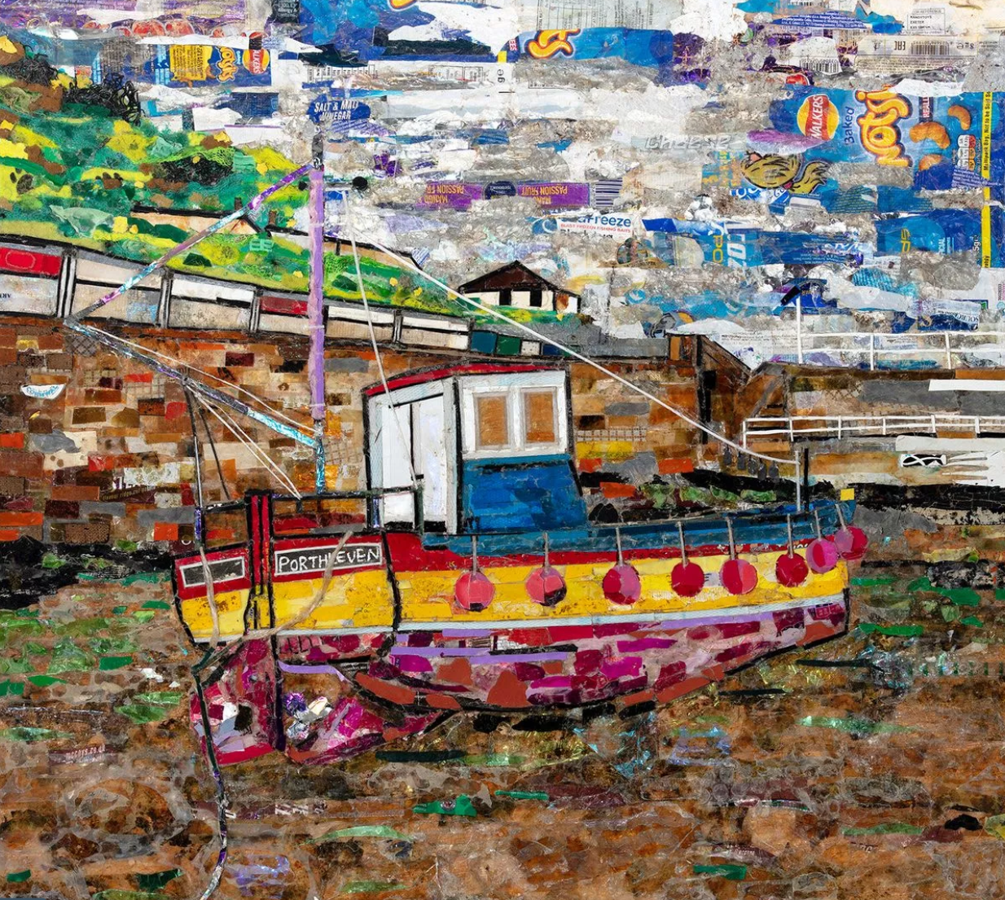  Using crisp packets and food packaging to make a class picture.  Young artist transforming Cornwall's beach litter into art - Cornwall Live  BISH art  Singing/music  Charanga – Reflect, rewind and replay  Dancing – Ocean Commotion |  | Creating with materials  Artist of the term – Bonnie Steward  Using crisp packets and food packaging to make a class picture.  Young artist transforming Cornwall's beach litter into art - Cornwall Live  BISH art  Singing/ music  Charanga - Reflect, rewind and replay  Dancing – Ocean Commotion |  | Creating with materials  Artist of the term – 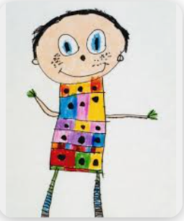  Children draw picture of themselves at end of reception and put picture in handmade lolly stick frame (decorated)  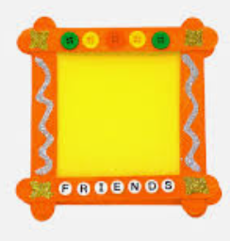  Singing/ music  Charanga - Reflect, rewind and replay  Dancing – Ocean Commotion

