Bude Primary Talk for Writing Long Term Plan
 | Autumn 1 | Autumn 2 | Spring 1 | Spring 2 | Summer 1 | Summer 2
EYFS  Fiction | Cumulative | Nursery Rhymes | Finding Tale | Cumulative | Cumulative | Wishing Tale
 | Warning Tale | Journey Tale | Cumulative | Cumulative | Cumulative | Cumulative
 | Wishing Tale | Finding Tale | Cumulative | Journey | Cumulative | Journey Tale
Non-Fictions | Recount | Instructions | Information | Instruction | Information | Recount
Year 1  Fiction | Cumulative | Journey Tale | Overcoming fear | Rags to riches | Defeating the Monster Tale | Finding Tale
Focus | Description | Characterisation | Openings and endings | Settings | Descriptions | Openings and endings
Non-Fiction | Recount  Poetry | Letter writing | Diary Entry  Poetry | Instructions  Poetry | Instructions | Information
Year 2  Fiction | Warning Tale | Journey Tale | Loosing Tale | Defeating the Monster | Wishing Tale | Character Flaw
Focus | Dialogue | Openings and endings | Setting | Characterisation | Suspense | Description
Non-fiction | Persuading | Recount  Poetry | Information | Discussion | Instruction | Explanation

 | Autumn 1 | Autumn 2 | Spring 1 | Spring 2 | Summer 1 | Summer 2
EYFS | Who am I? | Where can we go? | What’s in the egg? | What’s growing in the garden? | What’s that munching? | What’s in the sea?
Fiction | Cumulative | Cumulative/circular tale | Warning | Defeating the monster | Defeating the monster | Cumulative journey
 | Cumulative  We’re going on a bear hunt  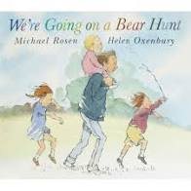 | Nursery rhymes  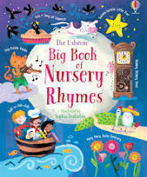 | Finding tale-  The Secret of the Egg  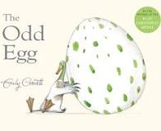 | Cumulative  The Enormous Turnip  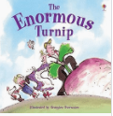 | Cumulative  The Very Hungry Caterpillar  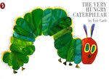 | Wishing tale-  The Three Wishes  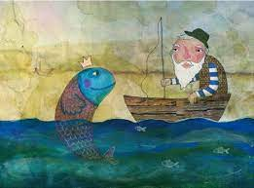
 | Warning tale  Goldilocks and the Three Bears: 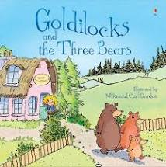 | Journey tale  Whatever next! By Jill Murphy  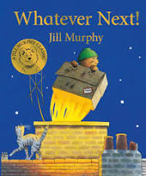 | Learn about different types of egg 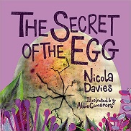 | A seed in need  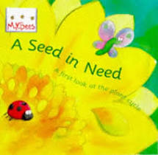 | Minibeasts facts powerpoint  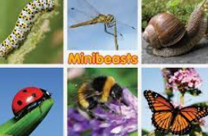 | Rockpool facts powerpoint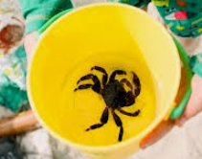
 | Incredible you  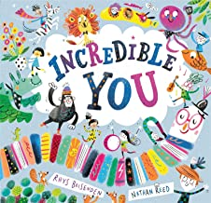 | Finding tale  Room on a broom by Julia Donaldson  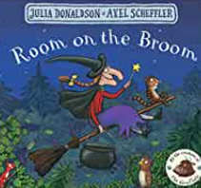 | Bumpus Jumpus Dinosaur Rumpus  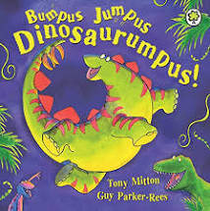 | It starts with a seed  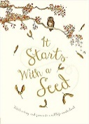 | Mad about minibeasts  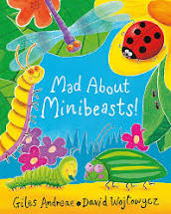 | Journey Tale  The snail and the whale  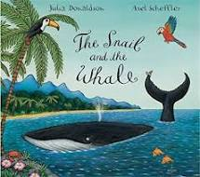  The magic box by Kit Wright
Focus | Joining in with the sounds. | Joining in with the dialogue | Time connecting language | Connectives | Adjectives, verbs and alliteration | Early dialogue
Plot | 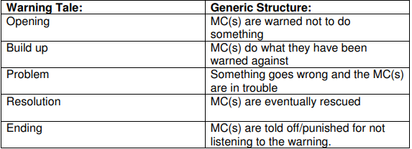  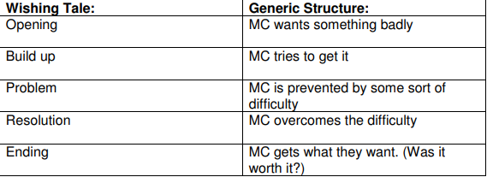 | 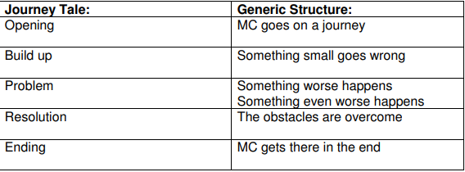  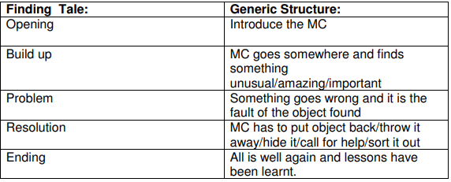 | 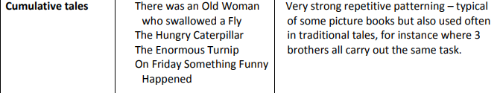
Non-Fictions | Recount | Instructions | Information | Instructions | Information | Recount
Reading area ideas | Where’s my teddy? Jez Alborough  Kipper’s Balloon – Jez Alborough  Brown Bear, Brown Bear what do you see? Eric Carle | Peace at last by Jill Murphy  Mrs Armitage on Wheels and  Mrs Armitage on the road – Quentin Blake  Jack and the Flum Flum Tree -Julia D | Stomp, Dinosaur, Stomp!  Zog by Julia Donaldson  Dinosaur Roar!  Harry and his bucketful of dinosaurs  The ugly duckling | Handa’s Surprise by Eileen Browne  Oliver’s vegetables  Supertato by Sue Hendra  The tiny seed | Snail Trail – Ruth Brown  The Bad Tempered Ladybird – Eric Carle  What the ladybird heard  Monkey Puzzle – Julia Donaldson  Planting a rainbow. Little Red Hen. | Duffy’s Lucky Escape  Billy’s Bucket  Rainbow fish  Commotion in the ocean  Mr Seahorse
Pie Corbett Reading Spine | 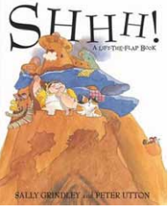  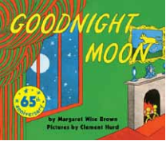  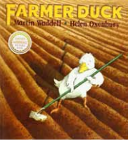  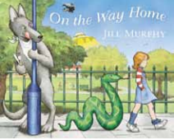  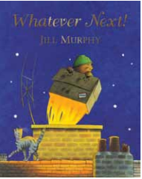  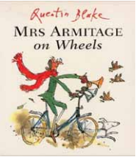  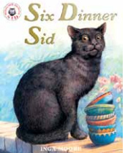  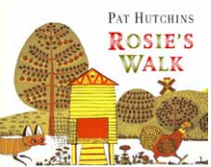  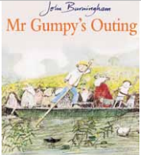  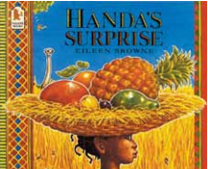  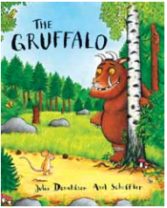  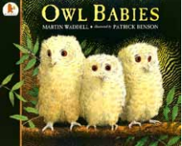
Year 1 | Amazing Me! | Once upon a time… | Home sweet home. | Up in the sky! | Fearsome creatures. | Coasts and Castles.
Knowledge and skills progression. | Handwriting: Sit correctly at a table, holding a pencil comfortably and correctly.  Form digits 0-9  Writing:  Punctuation and Grammar: Use the personal pronoun ‘I’.  Leave spaces between words.  Use a capital letter at the start of a sentence.  Composition: Write sentences by saying out loud what they are going to write about.  Write sentences by orally rehearsing before writing it.  Plan writing by saying what they are going to write about.  Spelling: To spell some words in a phonically plausible way, even if sometimes incorrect.  To read words that they have spelt.  Name the letters of the alphabet, in order and use letter names to distinguish between alternative spellings of the same sound. |  | Handwriting: Begin to form lower-case letters in the correct direction, starting and finishing in the right place.  Understand which letters belong to which handwriting ‘families’ and to practice these.  Writing:  Punctuation and Grammar: Use ‘and’ to join ideas within a sentence.  Begin to use other punctuation such as exclamation marks and question marks.  Use full stop accurately.  Composition: Sequence sentences to form short narratives.  Discuss what they have written with the teach or other pupils.  Read aloud their writing clearly enough to be heard by their peers and the teacher.  To start to engage readers by using adjectives to describe.  Spelling: Use -ing, -ed, -er and -est where no change is needed in the spelling of root words.  Write from memory simple sentences dictated by the teacher that include words using the GPCs and common exception words taught so far.  To spell simple compound words (e.g dustbin, football |  | Handwriting: Form capital letters  Name letters of the alphabet in order.  Writing:  Punctuation and Grammar: Attempt to use other conjunctions.  Make sure that word choices are relevant to the context and use word banks to support.  Begin to use adjectives to add detail to sentences.  Use capital letters for the names of people, places and days of the week.  Composition: Re-read what they have written to check that it makes sense and to independently begin to make changes.  To use a number of simple features of different text types to make relevant choices about subject matter and appropriate vocabulary choices.  Use sequences sentences in chronological order to recount an event/experiences (basic adverbials used eg First, then, next, after that)  Spelling: Use the prefix -un  Add prefixes and suffixes using the spelling rule for adding -s or -es as the plural marker for nouns and the third person singular marker for verbs.
Fiction | 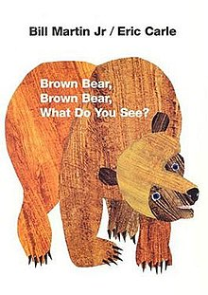  Repetitive Tale | Journey story  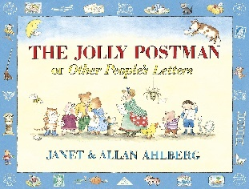 | 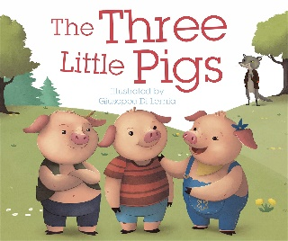  Overcoming fear | 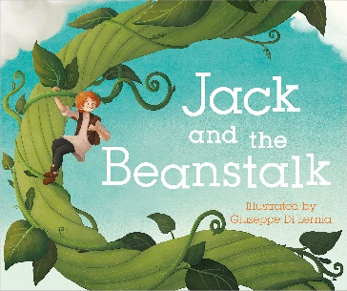  Rags to riches | 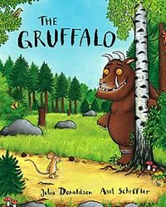  Defeating the monster | Finding tale  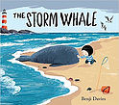
Focus | Description | Characterisation | Openings and endings | Setting | Description | Openings and endings
Plot |  | 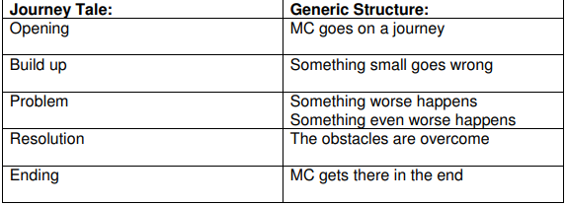 | 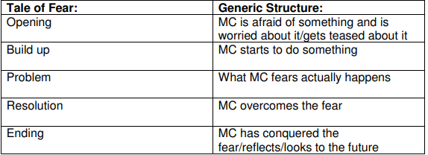 | 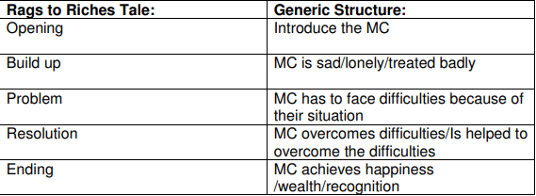 | 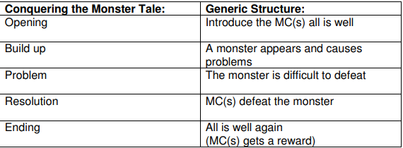 | 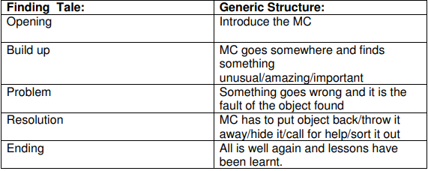
Non-Fiction | Recount  Poetry- Acrostic poems. | Letter writing | Diary Entry  Poetry- Revolting Rhymes Three Little Pigs Roald Dahl. | Instructions  Poetry- If I had wings-Pie Corbett. | Instructions- How to make Gruffalo Crumble. | Information- Tell me a dragon/ information broucher comparing London and Bude.  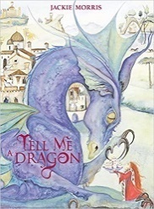
Book area ideas. | Funnybones  Super-duper me!  Titch  Only one you  The name jar  You choose  What makes me me!  Once there were giants.  All about families  What makes me me! | Little Red Hen  Gingerbread man  Goldilocks and the three bears.  Room on the broom.  The billy goats gruff.  Winnie the witch  The magic porridge pot.  Cinderella  Little red riding hood.  The Elves and the Shoemaker.  The jolly Christmas postman  The magic paintbrush  The emperor’s new clothes. | The three little wolves and the big bad pig.  In every house in every street.  Step inside homes through history.  The house that Jack built.  Iggy Peck: Architect  Belonging.  Mouse house.  Town mouse and country mouse. | Lila and the secret of rain.  Book of blooms  Tree: Seasons come and seasons go  The wind blew  Elmer and the rainbow  I am the seed that grew the tree  Journey  Amelia Earhart (Little people, big dreams)  Flying machines.  The great balloon hullabaloo | Superworm  The ugly five  Lost and found  Dear Zoo  The very hungry caterpillar  Giraffes cant dance  Rumble in the jungle  The gruffalos child  Oi Ardvark  Wonkey donkey  Hiary McClary  Elmer  The boy, the fox, the horse and the mole  What the ladybird heard  Monkey puzzle | Tiddler  Snail and the whale  The mermaid of Zennar  Zog  Rapunzel  The lighthouse keepers lunch.  Flotsam  Billys bucket  Mister seahorse  The singing mermaid  The princess and the pea  Rumpelstiltskin  The Queens knickers  Katie in London  Paddington
Pie Corbett  Reading Spine. | 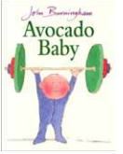  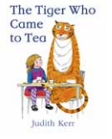  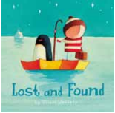  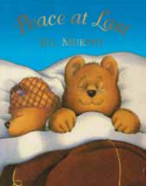  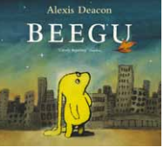  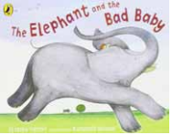  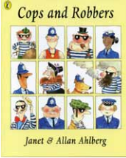  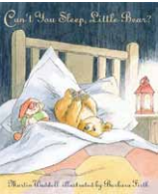  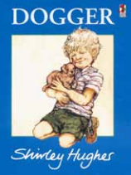  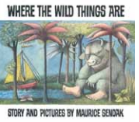  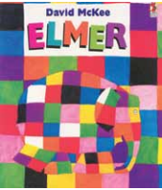  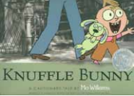
Year 2 | Habitats | Fire and Ice | Islands | Castles | Oh I do Love to be beside the seaside! | Plants and food
Knowledge and skills progression. | Handwriting: Use some of the diagonal and horizontal strokes needed to join letters.  Understand which letters, when adjacent one another are best left un-joined.  Write capital letters (and digits) of the correct size/orientation to one another.  Writing  Punctuation and Grammar: Make thoughtful and ambitious word choices including specific or technical vocabulary used in non-narrative writing.  Use full stops and capital letters mostly correctly.  Mostly use exclamation and question marks accurately to demarcate sentences.  Composition: Write for different purposes with an awareness of an increased amount of fiction and non-fiction structures.  Encapsulate what they want to say, sentence by sentence.  Spelling: Segment spoken words into phonemes and to represent these with graphemes, spelling many of these words correctly and making phonically plausible attempts at others.  To write, from memory, simple sentences dictated by the teacher that include words using the GPCs (grapheme phoneme correspondence), common exception words and punctuation taught so far. |  | Handwriting: Use spacing between words that reflects the size of the letters.  Writing  Punctuation and Grammar: Use expanded noun phrases to describe, expand and specify.  Use subordination  (when, if, that, because)  Use capital letters for the personal pronoun ‘I’ and most proper nouns.  Composition: Plan what they are going to write about, including writing down ideas and/or key words and new vocabulary.  Make simple additions, revisions and corrections to their own writing with the teacher and other pupils.  Use new vocabulary from their reading, their discussions about it and from their wider experiences.  Write from memory simple dictated sentences.  Spelling: To add suffixes to spell most words correctly in their writing e.g -ment, -ness, -ful, -less, -ly.  To learn the possessive singular apostrophe.  To self-correct misspellings of words that pupils have been taught to spell. |  | Handwriting: Form lower case letters of the correct size, relative to on another.  Writing  Punctuation and Grammar: Use sentences with different forms: statements, questions, exclamations and commands.  Use co-ordinations (or, and, but)  Use present and past tenses correctly and consistently including the progressive form.  Use adjectives, adverbs and expanded noun phrases to add detail and specify.  Begin to use commas to separate items in a list.  Sometimes use apostrophes for singular possession.  Composition: Reread to check that their writing makes sense and that the correct tense is used throughout.  Proofread to check for errors in spelling, grammar and punctuation.  Read aloud what they have written with appropriate intonation to make the meaning clear.  Spelling: Recognise new ways of spelling phonemes for which one or more spellings are already known and to learn some words with each spelling, including some common homophones (e.g bare/bear, blue/blew)  To spell more words with contracted forms e.g can’t, didn’t, hasn’t, couldn’t, it’s and I’ll.
Fiction | Warning tale  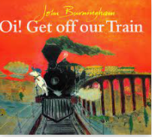 | Journey tale  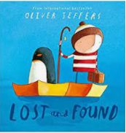 | 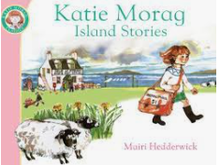  Loosing Tale | Defeating the monster  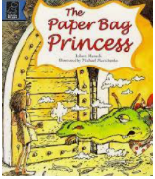 | Wishing Tale  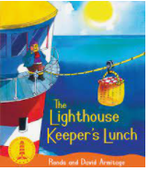 | Character Flaw  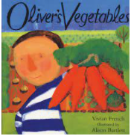
Focus | Dialogue | Openings and endings | Setting | Characterisation | Suspense | Description.
 | 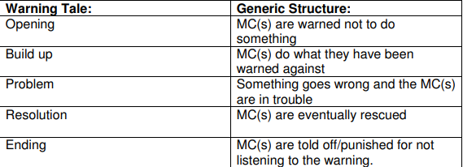 |  | 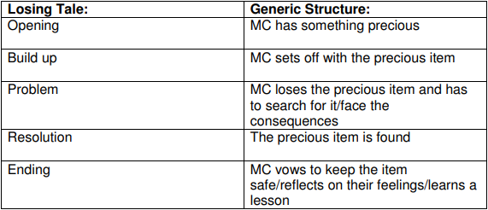 |  | 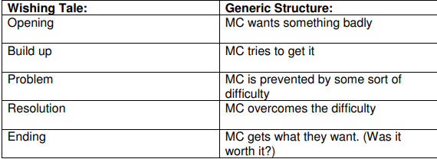 | 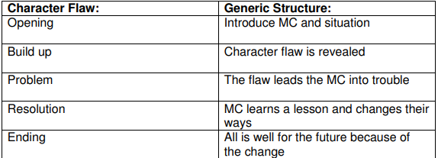
Non-fiction | Persuading | Recount | Information | Discussion | Instructions | Explanation
Book area Ideas | The variety of life  Whose Habitat is that?  Stuck  Animal Atlas  First Encyclopaedia of Our World  The big book of bugs  Superworm  Moth  Firefly Home  Insect Detective  The book of bees  Book of animals  Here we are  Home  Birds make Nests | The rainbow bear  Shackleton’s Journey  The last polar bears  Sky Song  The Penguin who wanted to find out  The Great explorer  A Dot in the snow  (Not sure what you mean by fire so left until I know more) | Grandads Island  Nims Island  Treasure Island  Troll  Snail and the whale  The Night pirates  Jolly Pirates | Journey  King Arthur  Zog  How to Catch a dragon  The story of Castles  George and the Dragon  The Princess and the Pea | At the beach  Sharing a shell  Secrets of the seashore  How does a lighthouse work?  Flotsam  Magic Beach | Jim and the beanstalk  Tree Seasons come and go  The Gardener  The Enormous Potato  It starts with a seed  Bonkers about beetroot  Katie and the sunflowers
Pie Corbett Reading spine | 